
(Accredited by NAAC “A+” Grade; CSE ,CSE(IoT), B.Tech
Program Accredited by NBA; Approved by AICTE, New Delhi, Affiliated to JNTUH)
Geethanjali College of Engineering and Technology

STATISTICS FOR MACHINE LEARNING
LABORATORY WORKBOOK
III Year B. Tech-I Semester (AY 2025-26)

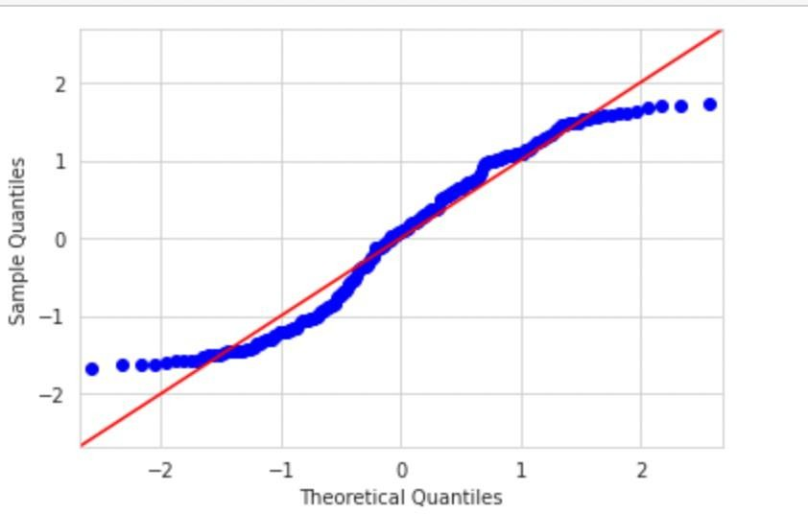
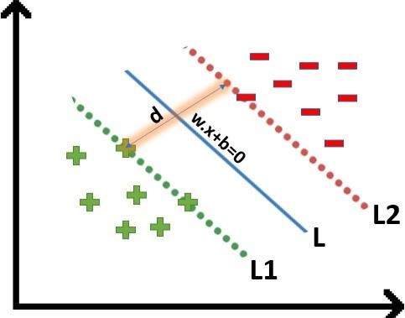

Name: ………………………………………………......................Roll No: ............………………
Branch: ……………………….…………………….......................Section: …………………….....

Geethanjali College of Engineering and Technology

AUTONOMOUS
(Accredited by NBA, NAAC “A+” Grade)

Cheeryal (V), Keesara (M), Medchal District – 501 301 (T S)



STATISTICS FOR MACHINE LEARNING LAB

Subject Code – (20MA31L01) LABAORATORY MANUAL
III Year B.Tech I Semester

Common to
MECHANICAL ENGINEERING

2025-2026

DEPARTMENT OF MECHANICAL ENGINEERING

Geethanjali College of Engineering and Technology
AUTONOMOUS
(Accredited by NBA, NAAC “A+” Grade)
Cheeryal (V), Keesara (M), Medchal District – 501 301 (T S)

CERTIFICATE

This is to certify that Mr. / Miss

has satisfactorily completed number of programmes in the Statistics for Machine

Learning lab.

Roll No: Branch:
Year : AcademicYear:

Head of the Department Faculty In-charge

Internal Examiner External Examiner

Geethanjali College of Engineering and Technology (Autonomous)
DEPARTMENT OF MECHANICAL ENGINEERING
(Name of the Subject/Lab Course): STATISTICS FOR MACHINE LEARNING
(Subject Code): 20MA31L01 Programme : UG
Branch : ME Version No : 1
Year : III Updated on : 06/0/2025

Semester : I No. of pages : 88
Classification status (Unrestricted / Restricted) Distribution List: Department, Lab, Lab In Charge
Prepared by: Updated by:
- Name : Dr A.Srinivasulu 1) Name :Dr G. Durga Priyadarsini
- Sign : 2) Sign :
- Design : Asst. Prof 3) Design : Associate Professor
- Date : 0 6 .02.2025 4) Date : 0 6 .06.2025
Verified by :  - Name : Dr V.S.Triveni  - Sign :  - Design : Professor  - Date :06.06.2025 | - For Q.C Only.  - Name :  - Sign :  - Design :  - Date :
Approved by : (HOD )
- Name : Dr A.Sree Lakshmi
- Sign :
- Date :

Geethanjali College of Engineering and Technology AUTONOMOUS
Subject code: 20MA31L01
L | T | P/D | C
- | - | 2/- | 1

Pre-requisite(s): 20MA31001- Statistics for Machine Learning Course Outcomes:
At the end of the course, student would be able to use R software to:
CO1: Construct frequency distribution for the given data.
CO2: Obtain specified set of samples from large data through random variables using Acceptance-Rejection (AR) algorithm.
CO3: Estimate and test the significance of the specified population parameter(s) for the given data.
CO4: Reduce the dimensionality of large data sets using principal component analysis (PCA),Logistic Regression(LR),K-means clustering and Support Vector Machine(SVM) for selecting variables

List of Experiments:
- Introduction to R Programming
- Introduction to descriptive statistics using R (Frequency Distribution and Cumulative Distribution Function)
- Acceptance/Rejection Sampling in R
- Maximum likelihood and method of moments estimation. Testing of Hypothesis based on Z-test. Concept of p-value in R
- Testing of hypothesis based on t-test, chi-square test and F-test, Confidence interval estimation in R
- Multiple linear regression: Outlier analysis, residual analysis, test for normality, multi-collinearity in R
- Logistic Regression in R
- Classification with SVM in R
- Dimensionality reduction with PCA in R and K-means Clustering in R
- Kernel PCA and Kernel SVM in R

List of Additional programs
- Generating Functions (Binomial, Poisson, Uniform, Normal and Exponential) using R Programming
- Simple Linear Regression :Testing overall hypothesis and testing significance of variables
- Multiple linear regression: Testing overall hypothesis and testing significance of individual variables, model selections and prediction in R programming.

Vision of the Institute:
Geethanjali visualizes dissemination of knowledge and skills to students, who would eventually contribute to the well-being of the people of the nation and global community.

Mission of the Institute:
- To impart adequate fundamental knowledge in all basic sciences and engineering, technical and Interpersonal skills to students.
- To bring out creativity in students that would promote innovation, research and entrepreneurship.
- To Preserve and promote cultural heritage, humanistic and spiritual values promoting peace and harmony in society.

Vision of the Department:

Department of ME

The Mechanical Engineering department strives to be recognized globally for outstanding education and research, imparting quality education, churning well-qualified engineers, who are creative, innovative, and entrepreneurial, solving problems for societal development.
Mission of the Department:

Department of ME

Imparting quality education to students to enhance their skills and make them globally competitive.

Prepare graduates to engage in life-long learning, possess intellectual capabilities, serving society with a strong commitment to their profession, meeting technical challenges and exhibiting ethical responsibility for societal development. To be a center of excellence in instruction, innovation in research and scholarship, and service to the stake holders, the profession, and the public.

- Conduct quality research, create opportunities for students and faculty to showcase their talent, disseminate knowledge, and promote community development, leading to peace and harmony in society.

Program Educational Objectives (PEO’s):
ME
PEO 1: To prepare students with strong fundamental knowledge in basic sciences mathematics, engineering courses which would facilitate them find gainful employment with a sense of appreciation to pursue life-long learning for professional development.
PEO 2: To inculcate problem solving skills in students, imbibing creativity and innovation which would enable them to develop modern machinery involving cutting edge technologies of Multidisciplinary nature for societal development.
PEO 3: To develop critical thinking with an aptitude to conduct research and development, instill professional ethics, develop effective communication and interpersonal skills with positive attitude to contribute significantly towards their chosen profession, thereby supporting community development.

Program Outcomes (POs):
- Engineering Knowledge: Apply knowledge of mathematics, natural science, computing, engineering fundamentals and an engineering specialization as specified in WK1 to WK4 respectively to develop to the solution of complex engineering problems.

- Problem Analysis: Identify, formulate, review research literature and analyze complex engineering problems reaching substantiated conclusions with consideration for sustainable development. (WK1 to WK4)
- Design/Development of Solutions: Design creative solutions for complex engineering problems and design/develop systems/components/processes to meet identified needs with consideration for the public health and safety, whole-life cost, net zero carbon, culture, society and environment as required. (WK5)
- Conduct Investigations of Complex Problems: Conduct investigations of complex engineering problems using research-based knowledge including design of experiments, modelling, analysis & interpretation of data to provide valid conclusions. (WK8).
- Engineering Tool Usage: Create, select and apply appropriate techniques, resources and modern engineering & IT tools, including prediction and modelling recognizing their limitations to solve complex engineering problems. (WK2 and WK6)
- The Engineer and The World: Analyze and evaluate societal and environmental aspects while solving complex engineering problems for its impact on sustainability with reference to economy, health, safety, legal framework, culture and environment. (WK1, WK5, and WK7).
- Ethics: Apply ethical principles and commit to professional ethics, human values, diversity and inclusion; adhere to national & international laws. (WK9)
- Individual and Collaborative Team work: Function effectively as an individual, and as a member or leader in diverse/multi-disciplinary teams.
- Communication: Communicate effectively and inclusively within the engineering community and society at large, such as being able to comprehend and write effective reports and design documentation, make

effective presentations considering cultural, language, and learning differences
- Project Management and Finance: Apply knowledge and understanding of engineering management principles and economic decision-making and apply these to one’s own work, as a member and leader in a team, and to manage projects and in multidisciplinary environments.
- Life-Long Learning: Recognize the need for, and have the preparation and ability for i) independent and life-long learning ii) adaptability to new and emerging technologies and iii) critical thinking in the broadest context of technological change. (WK8)
WK1: A systematic, theory-based understanding of the natural sciences applicable to the discipline and awareness of relevant social sciences.
WK2: Conceptually-based mathematics, numerical analysis, data analysis, statistics and formal aspects of computer and information science to support detailed analysis and modelling applicable to the discipline.
WK3: A systematic, theory-based formulation of engineering fundamentals required in the engineering discipline.
WK4: Engineering specialist knowledge that provides theoretical frameworks and bodies of knowledge for the accepted practice areas in the engineering discipline; much is at the forefront of the discipline.
WK5: Knowledge, including efficient resource use, environmental impacts, whole-life cost,re- use of resources, net zero carbon, and similar concepts, that supports engineering design and operations in a practice area.
WK6: Knowledge of engineering practice (technology) in the practice areas in theengineering discipline. WK7: Knowledge of the role of engineering insociety and identified issues in engineering practice in the discipline, such as the professional responsibility of an engineer topublic safety and sustainable development. WK8: Engagement with selected knowledge in the current research literature of the discipline, awareness of the power of critical thinking and creative approaches to evaluate emerging issues.
WK9: Ethics, inclusive behavior and conduct. Knowledge of professional ethics, responsibilities, and norms of engineering practice. Awareness of the need for diversity by reason of ethnicity, gender, age, physical ability etc. with mutual understanding andrespect, and of inclusive attitudes.

Program Specific Outcomes (PSOs):

ME
PSO 1: Apply Continuity, Energy and Momentum equations to mechanical systems, design and perform experiments in all fields of mechanical engineering
PSO 2: Able to analyze, design and develop/model mechanical and its allied systems using software tools such as AUTOCAD, ANSYS, Creo etc.
PSO 3: Able to design layouts for process and manufacturing industry taking into consideration optimization of resources for effective operation and maintenance.

Mapping of Lab Course outcomes with Program outcomes:
ME
CO-  PO | PO  1 | PO  2 | PO  3 | PO  4 | PO  5 | PO  6 | PO  7 | PO  8 | PO  9 | PO  10 | PO  11 | PS  O1 | PS  O2 | PS  O3
CO1 | 3 | 2 | - | - | - | - | - | - | - | 2 | - | 2 | - | -
CO2 | 3 | 2 | - | - | - | - | - | - | - | 2 | - | 2 | - | -
CO3 | 3 | 2 | - | 3 | - | - | - | - | - | 3 | - | 3 | - | -
CO4 | 3 | 2 | 3 | 3 | - | - | - | - | - | 3 | - | 3 | - | -

- | No Correlation | 1 | Slight (low) | 2 | Moderate (medium) | 3 | Substantial (High)
Prerequisites:
Statistics for Machine Learning (20MA31001)
INSTRUCTIONS TO THE STUDENTS:
- Students are required to attend all labs.
- Students should be dressed in formals when attending the laboratory sessions.
- Students will work individually in computer laboratories.
- While coming to the lab bring the observation book and Work book etc.
- Before coming to the lab, prepare the pre-lab questions. Read through the lab experiment to familiarize you.
- Utilize 3 hours’ time properly to perform the experiment and noting down the outputs.
- If the experiment is not completed in the prescribed time, the pending work has to be done in the leisure hour or extended hours.
- You will be expected to submit the completed work book according to the deadlines set up by your instructor.

INSTRUCTIONS TO LABORATORY TEACHERS:
- Observation book and lab records submitted for the lab work are to be checked and signed before the next lab session.
- Students should be instructed to switch ON the power supply after the connections are checked by the lab assistant / teacher.

- The promptness of submission should be strictly insisted by awarding the marks accordingly.
- Ask Viva Voce questions at the end of the experiment.
- Do not allow students who come late to the lab class.
- Encourage the students to do the experiments innovatively.
- Fill Continuous Evaluation Sheet, on regular basis.
- Ensure that the students are dressed in formals

Evaluation pattern:
Total Lab Marks –100 (Internal - 40 Marks & External – 60 Marks) Internal Assessment:
- Continuous valuation is done for 15 Marks based on:
  - Submission of workbook in time (5 Marks)
  - Performance of Program (5 Marks)
  - Viva-Voce (5 Marks)
- During the semester, two Lab Internal examinations are conducted for 15 Marks and average will be considered.
- Project presentation Seminar conference Presentation carries 10 marks

External Assessment:
At the end of semester, external lab exam is conducted for 60 Marks with one external examiner and one internal examiner.as per regulation.
- Write up and program code (25 Marks)
- Execution of Program (25 Marks)
- Viva-Voce (10 Marks)

PERFORMANCE INDICATOR
S  No. | Name of the Program | Page No. | Date of Programme | Date of Submission | Marks awarded | Faculty Sign. | Remarks
1 | Introduction to R Programming
2 | Introduction to descriptive statistics using R (Frequency Distribution and Cumulative Distribution Function)
3 | Acceptance/Rejection Sampling in R
4 | Maximum likelihood and method of moments estimation. Testing of  Hypothesis based on Z-test. Concept of p- value in R
5 | Testing of hypothesis based on t-test, chi- square test and F-test.  Confidence interval estimation in R
6 | Multiple linear regression: Outlier analysis, residual analysis, test for normality, multi- collinearity in R
7 | Logistic Regression in R
8 | Classification with SVM in R
9 | Dimensionality reduction with PCA in R and K-means Clustering in R
10 | Kernel SVM in R

 | ADDITIONAL PROGRAMMES
S  No. | Name of the Program | Page No. | Date of Programme | Date of Submission | Marks awarded | Faculty Sign. | Remarks
1 | Generating Functions (Binomial, Poisson, Uniform, Normal and Exponential) using R programming
2 | Simple Linear Regression in R programming.
3 | Multiple linear regression: Testing over all hypothesis and testing  significance of individual variables, model selections and prediction in R programming

S No. | INDEX | Page No.
1 | Introduction to R Programming
2 | Introduction to descriptive statistics using R (Frequency Distribution and  Cumulative Distribution Function)
3 | Acceptance/Rejection Sampling in R
4 | Maximum likelihood and method of moments estimation. Testing of  Hypothesis based on Z-test. Concept of p-value in R
5 | Testing of hypothesis based on t-test, chi-square test and F-test.  Confidence interval estimation in R
6 | Multiple linear regression: Outlier analysis, residual analysis, test for  normality, multi-collinearity in R
7 | Logistic Regression in R
8 | Classification with SVM in R
9 | Dimensionality reduction with PCA in R and K-means Clustering in R
10 | Kernel SVM in R
 | Additional Programmes
1 | Generating Functions (Binomial, Poisson, Uniform, Normal and Exponential) using R programming
2 | Linear Regression :Testing overall hypothesis and testing significance of  Variables
3 | Multiple linear regression: Testing overall hypothesis and testing  significance of individual variables, model selections and prediction in R programming

- Introduction to R Programming
R is a programming language and free software environment for statistical computing and graphics that is supported by the R Foundation for Statistical Computing. The R language is widely used among statisticians and data miners for developing statistical software and data analysis.
R is a programming language and software environment for statistical analysis, graphics representation and reporting.
The following are the important features of R
  - R is a well-developed, simple and effective programming language which includes conditionals, loops; user defined recursive functions and input and output facilities.
  - R has an effective data handling and storage facility,
  - R provides a suite of operators for calculations on arrays, lists, vectors and matrices.
  - R provides a large, coherent and integrated collection of tools for data analysis.
  - R provides graphical facilities for data analysis and display either directly at the computer or printing at the papers.
To Install R and R Packages:
- Open an internet browser and go to www.r-project.org.
- Click the "download R" link in the middle of the page under "Getting Started."
- Select a CRAN location (a mirror site) and click the corresponding link.
- Click on the "Download R for WINDOWS" link at the top of the page.
- Click on the file containing the latest version of R under "Files."
- Save the .pkg file, double-click it to open, and follow the installation instructions.
- Now that R is installed, you need to download and install R Studio. To Install R Studio:
  - Go to www.rstudio.comand click on the "Download R Studio" button.
  - Click on "Download R Studio Desktop."
  - Click on the version recommended for your system, or the latest Mac version, save the .dmg file on your computer, double-click it to open, and then drag and drop it to your applications folder.

Install R Packages:
- Download and install a package (you only need to do this once).
- To use the package, invoke the library (package) command to load it into the current session. (You need to do this once in each session, unless you customize your environment to automatically load it each time).

Installing and Loading Packages:
R to load the package’s library in R session
  - library ("MASS") #R now knows all the functions that are scanned in the MASS package
  - Basics and R as a Calculator:
    - 31 * 78 # Multiplication
[1] 2418
    - 697/41 #division
[1] 17
    - Assign the value of 39 to x x<-39
      - x
[1] 39
    - Assign the value of 22 to y
      - y<-22
      - y
[1] 22
    - Make z the value of x - y
      - z<- x - y
    - Display the value of z in the console
      - z
[1] 17
    - Find 10 random numbers between 1 and100. (Hint: you can use sample() function)
      - sample(1:100,10)
[1] 77 74 89 23 39 84 63 12 91 16

- Example: Find the value of 21 is multiplied by 23, 32 is multiplied by 62; 1256 divided by 2; Assign the value of 26 to x variable, 33 to y variable and hence find the value of z such that z = x+y; x-y;
R Code with Output:
  - 21*23
[1] 483
  - 32*62
[1] 1984
  - 1256/2
[1] 628
  - x=26
  - y=33
  - z=x+y
  - z
[1] 59
  - x-y
[1] -7

- Example: Find 5 random numbers between 1 to 100 using sample function
R Code with Output:
  - sample (1:100,5)

[1] 23 94 30 62 45
  - Creating Vectors:
A vector is a basic data structure of R containing the same type of data.
R Code for vector calculations:

x = c(observations / data) | # Store the observations in x
x+y  x-y x*y | # Addition of two vectors  Subtraction of two vectors Multiplication of two vectors
- Example: The numbers below are the first ten days of rainfall amounts in 1996. Read them into a vector using the vector function named as “rainfall”
0.1, 0.6, 33.8, 1.9, 9.6, 4.3, 33.7, 0.3, 0.0, 0.1
R-Code with Output:
- rainfall = c (0.1,0.6,33.8,1.9,9.6,4.3,33.7,0.3,0.0,0.1)
- rainfall
[1] 0.1 0.6 33.8 1.9 9.6 4.3 33.7 0.3 0.0 0.1

- Example: Find the addition, subtraction and multiplication of two vectors A= 20,22,24,25,21,26,25,26,21,25,26,24,25,25,26,25,24,25,26,25
B= 15,14,15,16,15,14,18,16,14,15,15,17,15,15,14,15,16,17,18,19
R-Code with Output:
A=c(20,22,24,25,21,26,25,26,21,25,26,24,25,25,26,25,24,25,26,25)
B=c(15,14,15,16,15,14,18,16,14,15,15,17,15,15,14,15,16,17,18,19)
A B

A=c(20,22,24,25,21,26,25,26,21,25,26,24,25,25,26,25,24,25,26,25)
B=c(15,14,15,16,15,14,18,16,14,15,15,17,15,15,14,15,16,17,18,19)

A+B
- A+B
[1] 35 36 39 41 36 40 43 42 35 40 41 41 40 40 40 40 40 42 44 44

A-B
- A-B
[1] 5 8 9 9 6 12 7 10 7 10 11 7 10 10 12 10 8 8 8 6

A*B
- A*B
300 308 360 400 315 364 450 416 294 375 390 408 375 375 364 375 384 425
468 475

  - Creating Matrices:
To create matrices we will use the matrix() function. The matrix() function takes the following arguments:
- data an R object (this could be a vector).
- nrow the desired number of rows.
- ncol the desired number of columns.
- by row a logical statement to populate the matrix by either row or by column
R Code for Matrix Calculations:

A=matrix(c(data),nrow=no.of rows, ncol=no.ofcolumns, byrow=TRUE)
# Store the data in matrix A
A+B, A-B, A%*%B  t(A) | # Addition, Subtraction  Multiplication of two matrices, Transpose of a matrix
rankMatrix(A) | # Rank of a matrix
eigen(A) | # Eigen values and eigen vectors

- Example: If x is a matrix specified by the R command x = matrix(nrow=3, ncol=3, data=c(1,8,2,1,5,4,3,9,6), byrow=TRUE), then the output of the R command x%*%t(x) is? R-Code with Output:

- x=matrix(nrow=3,ncol=3,data=c(1,8,2,1,5,4,3,9,6), byrow =TRUE)

- x%*%t(x)

[,1] | [,2] | [,3]
[1,] 69 | 49 | 87
[2,] 49 | 42 | 72
[3,] 87 | 72 | 126

 | 0 | 3 | 1 | 0 | 0 | 1
2. Example: If | A = [5 | 1 | −1] and B = | [0 | 1 | 0] are two | matrices then check whether the
1 2 1 1 0 1
two matrices satisfy commutative property or not. And also find transpose of each matrix using R program.
- R-Code with Output:
A=matrix(c(0,3,1,5,1,-1,1,2,1),nrow=3, ncol=3, byrow=TRUE) A
B=matrix(c(0,0,1,0,1,0,1,0,1),nrow=3, ncol=3, byrow=TRUE) B

A+B
A=matrix(c(0,3,1,5,1,-1,1,2,1),nrow=3, ncol=3, byrow=TRUE)
- A
 | [,1] | [,2] | [,3]
[1,] | 0 | 3 | 1
[2,] | 5 | 1 | -1
[3,] | 1 | 2 | 1
- B=matrix(c(0,0,1,0,1,0,1,0,1),nrow=3, ncol=3, byrow=TRUE)
- B
 | [,1] | [,2] | [,3]
[1,] | 0 | 0 | 1
[2,] | 0 | 1 | 0
[3,]  >A+B | 1  [,1] | 0  [,2] | 1  [,3]
[1,] | 0 | 3 | 2
[2,] | 5 | 2 | -1
[3,] | 2 | 2 | 2
B+A
 | [,1] | [,2] | [,3]
[1,] | 0 | 3 | 2
[2,] | 5 | 2 | -1
[3,] | 2 | 2 | 2

A+B=B+A

Under addition A & B matrices satisfy Commutative property.

- A%*%B
[,1] | [,2] | [,3]
[1,] 1 | 3 | 1
[2,] -1 | 1 | 4
[3,] 1 | 2 | 2
B%*%A  [,1] | [,2] | [,3]
[1,] 1 | 2 | 1
[2,] 5 | 1 | -1
[3,] 1 | 5 | 2

Under Multiplication A & B matrices does not satisfy commutative property.
- R-Code with Output:
t(A)
t(A)
 | [,1] | [,2] | [,3]
[1,] | 0 | 5 | 1
[2,] | 3 | 1 | 2
[3,] t(B) | 1 | -1 | 1
t(B) | [,1] | [,2] | [,3]
[1,] | 0 | 0 | 1
[2,] | 0 | 1 | 0
[3,] | 1 | 0 | 1

- Example: Find the rank of a matrix A=
3  ⎡2  ⎢  0 | 2  1  0 | 4  2  3 | 0  1  −2 | −4  5  1 | ⎤  ⎥
⎢4 | 5 | 1 | 1 | 2 | ⎥
⎢2 | 1 | 5 | −1 | 0 | ⎥
[1 | 2 | 2 | 2 | 1 | ]

R-Code with Output:
A=matrix(c(3,2,4,0,-4,2,1,2,1,5,0,0,3,-2,1,4,5,1,1,2,2,1,5,-
1,0,1,2,2,2,1),nrow=6,ncol=5, byrow=TRUE) A
A
 | [,1] | [,2] | [,3] | [,4] | [,5]
[1,] | 3 | 2 | 4 | 0 | -4
[2,] | 2 | 1 | 2 | 1 | 5
[3,] | 0 | 0 | 3 | -2 | 1
[4,] | 4 | 5 | 1 | 1 | 2
[5,] | 2 | 1 | 5 | -1 | 0
[6,] | 1 | 2 | 2 | 2 | 1
print(rankMatrix(A))
[1] 5

1 8 9 16
- Example: Find the eigen values and eigen vectors of a given matrix A=[2 7 10 15]
3 6 11 14
4 5 12 13
R-Code with Output:
A=matrix(c(1,8,9,16,2,7,10,15,3,6,11,14,4,5,12,13),nrow=4,ncol=4,byrow=TRUE)
A A=matrix(c(1,8,9,16,2,7,10,15,3,6,11,14,4,5,12,13),nrow=4,ncol=4,byrow=TRUE)
- A

[,1] [,2] [,3] [,4]
[1,] | 1 8 | 9 16
[2,] | 2 7 | 10 15
[3,] | 3 6 | 11 14
[4,] | 4 5 | 12 13
print(eigen(A)) eigen() decomposition
$values
[1] 3.400000e+01 -2.000000e+00 -2.608772e-15 -5.588953e-16
$vectors
[,1] | [,2] | [,3] | [,4]
[1,] -0.5 | -0.82323920 | 0.6740714 | 0.82533832
[2,] -0.5 | -0.42274445 | 0.6563350 | 0.33233043
[3,] -0.5 | -0.02224971 | -0.2483414 | -0.45488432
[4,] -0.5 | 0.37824504 | -0.2306049 | 0.03812357

Viva Questions:
- Write the syntax for installing package MASS? Ans. install.packages(“MASS”)

- Write the syntax to load MASS package in library? Ans. Library(MASS)
- Write the R code to find the value of Z = X+Y. where X=26, Y = -10. Ans. Z = 16

  - Sequence & Drawing a Scatterplot
- Example: Print Numbers from 0 to 5 by the difference 0.5
R-Code with Output:
seq(from = 0, to = 5, by = 0.5)
seq(from = 0, to = 5, by = 0.5)
[1] 0.0 0.5 1.0 1.5 2.0 2.5 3.0 3.5 4.0 4.5 5.0

- Example: carage :5,7,8,7,2,2,9,4,11,12,9,6
Carspeed :99,86,87,88,111,103,87,94,78,77,85,86
Show these two variables in scatter plot and identify is there any relationship between these two variables.
R-Code with Output:
carage<- c(5,7,8,7,2,2,9,4,11,12,9,6)
carspeed<- c(99,86,87,88,111,103,87,94,78,77,85,86)
carage
[1] 5 7 8 7 2 2 9 4 11 12 9 6
carspeed
[1] 99 86 87 88 111 103 87 94 78 77 85 86
plot(carage, carspeed, main="Observation of Cars", xlab="Car age", ylab="Car speed") abline(lm(carspeed ~ carage), col = "blue")

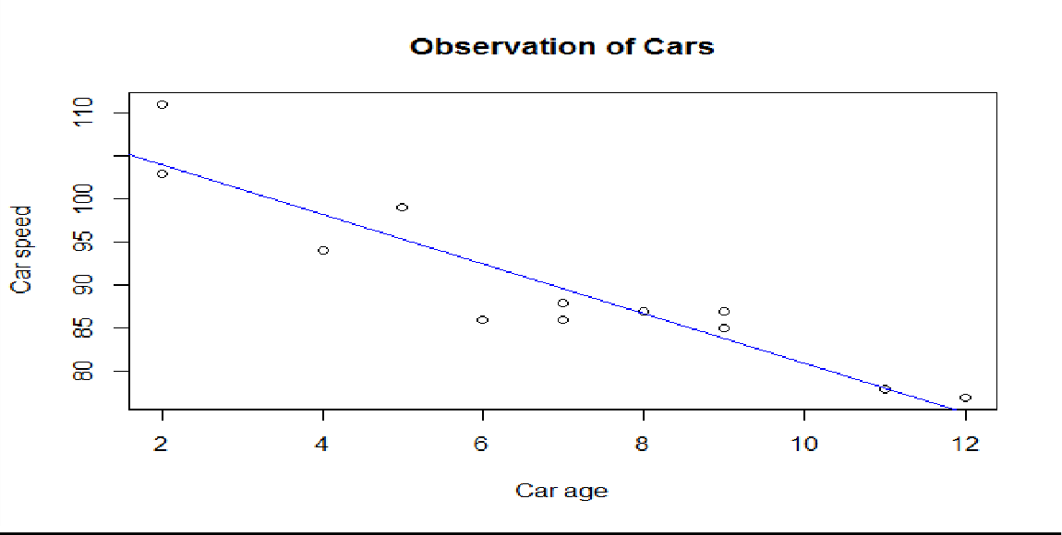
The x-axis shows how old the car is and y-axis shows the speed of the car when it passes. It seems that the newer the car, the faster it drives.

- Introduction to descriptive statistics using R (Frequency Distribution and Cumulative Distribution Function)
Absolute Frequency, Relative Frequency:
The number of observations in a particular class / category is called the Absolute Frequency or
Frequency.
The number of observations in a particular class / category is divided by total frequency is called
Relative Frequency.
  - Absolute and Relative Frequency. R Code:
table(data vector) #creates the absolute frequency of the data vector of the given data Enter data as x
table(x) # displays Absolute Frequencies
table(x)/length(x) # displays Relative Frequencies
- Example: Results of 10 persons declared in two categories as Pass (P) and Fail (F) is categorized as 1 and 2 respectively. Find Absolute and Relative Frequencies.
P, F, P, F, F, P, P, F, P, P
1, 2, 1, 2, 2, 1, 1, 2, 1, 1

R Code with Output:
- x=c(1,2,1,2,2,1,1,2,1,1)
- table(x) > table(x)/length(x)

x x
1 2 1 2
6 4 0.6 0.4

- Example: The time (in minutes) taken to complete the puzzle was recorded as follows and stored in a data vector as puzzle time. Find Absolute and Relative frequencies. 8,13,21,9,15,9,21,13,8,8,13,15,8,21,9,15,8,13,21
R Code with Output:
  - x=c(8,13,21,9,15,9,21,13,8,8,13,15,8,21,9,15,8,13,21)
  - table(x) x
8 9 13 15 21
5 3 4 3 4

  - table(x)/length(x) x
8 9 13 15 21
0.2631579 0.1578947 0.2105263 0.1578947 0.2105263

  - Frequency Distribution: Arrangement of ungrouped data in the form of group is called Frequency Distribution of data.
Algorithm:
    - First step is to find the “range” of the data values which can be partitioned into class interval.Use command range which returns a vector containing the minimum and maximum of all the given arguments.
    - Create a sequence starting from lower limit to upper limit of given set of observations at an interval of width specified in the given problem.
    - Now we need to convert Numeric to Factor using a command cut
    - Now we can compute the absolute frequency of given data in each width interval with the
table()
    - Use the cbind function to print the frequency distribution in column format.
    - To compute the relative frequency distribution of given data in each width interval with
table() by length().
  - Cumulative Distribution Function (CDF) for data: It gives us an idea about the cumulative frequencies up to a certain point of the given data using cumsum().
R Code:
>x=c(data vector)
>range(x) #returns a vector containing the minimum and maximum of all the given arguments.
>breaks = seq(minimum value, maximum value, by=specified width)
# Sequence at interval of specified width.
>C_I=cut(x, breaks, right = FALSE) #divides the range of data vector into intervals and codes
the values
in data vector according to which interval they fall
>Freq=table(C_I) # gives the absolute frequency of the variable of the data file which generates the
frequency distribution of the data on variable
>cbind(Freq) # print the frequency distribution in column format

>Rel_Freq=table(C_I)/length(C_I) #gives the relative frequency of the variable of the data file
which
generates the frequency distribution of the data on variable
>cbind(Rel_Freq) # print the relative frequency distribution in column format.
R Code for Cumulative Distribution function:
>Cum_Freq=cumsum(Freq) #returns a vector whose elements are the cumulative sums of the elements
of the absolute frequency distribution.
>cbind(Cum_Freq) # print the cumulative frequency distribution in column format
Note: Suppose if we want to display the total Frequency distribution table consisting of Absolute Frequency, Relative Frequency and Cumulative Frequency in column Format then:
- cbind(Freq, Rel_Freq, Cum_Freq)
- Example:
Following are the 50 test scores for male students in an examination.
79, 70, 85, 64, 41, 69, 66, 28, 89, 47, 88, 72, 21, 81, 75, 72, 55, 35, 56, 80, 68, 52, 49, 35, 20, 30,
23, 48, 90, 24, 58, 65, 29, 50, 67, 37, 42, 36, 86, 63, 78, 84, 60, 22, 57, 61, 32, 27, 73, 31.
  - Write R code to construct frequency distribution table of width 10.
  - And also find relative frequency distribution and cumulative frequency distribution for the male
students.
  - Represent the above (a) and (b) in column format.
R code with Output:
x=c(79, 70, 85, 64, 41, 69, 66, 28, 89, 47, 88, 72, 21, 81, 75, 72, 55, 35, 56, 80, 68, 52,
49, 35, 20, 30, 23, 48, 90, 24, 58, 65, 29, 50, 67, 37, 42, 36, 86, 63, 78, 84, 60, 22, 57, 61,
32, 27, 73, 31)
x
[1] 79 70 85 64 41 69 66 28 89 47 88 72 21 81 75 72 55 35 56 80 68 52 49 35
20 30 23 48
[29] 90 24 58 65 29 50 67 37 42 36 86 63 78 84 60 22 57 61 32 27 73 31
range(x)
range(x)
[1] 20 90
breaks = seq(20, 100, by=10) breaks
breaks = seq(20, 100, by=10)
- breaks
[1] 20 30 40 50 60 70 80 90 100
C_I=cut(x, breaks, right = FALSE) Freq=table(C_I)
Freq C_I

C_I
[20,30) [30,40) | [40,50) [50,60) | [60,70) | [70,80) | [80,90) | [90,100)
8 7 | 5 6 | 9 | 7 | 7 | 1
Rel_Freq=table(C_I)/length(C_I) Rel_Freq
Rel_Freq=table(C_I)/length(C_I)
- Rel_Freq C_I
[20,30) [30,40) | [40,50) [50,60) | [60,70) | [70,80) | [80,90) | [90,100)
0.16 0.14 | 0.10 0.12 | 0.18 | 0.14 | 0.14 | 0.02
Cum_Freq=cumsum(Freq) Cum_Freq
Cum_Freq=cumsum(Freq)
- Cum_Freq
[20,30) [30,40) | [40,50) [50,60) | [60,70) | [70,80) | [80,90) | [90,100)
8 15 | 20 26 | 35 | 42 | 49 | 50
cbind(Freq, Rel_Freq, Cum_Freq)
cbind(Freq, Rel_Freq, Cum_Freq) Freq Rel_Freq Cum_Freq
[20,30) | 8 | 0.16 | 8
[30,40) | 7 | 0.14 | 15
[40,50) | 5 | 0.10 | 20
[50,60) | 6 | 0.12 | 26
[60,70) | 9 | 0.18 | 35
[70,80) | 7 | 0.14 | 42
[80,90) | 7 | 0.14 | 49
[90,100) | 1 | 0.02 | 50

- Example:
Following are the scores of 250 students in a test with minimum and maximum marks being 0 and 100 respectively. The scores are stored in a data vector named scores.
21.08, 13.76, 75.89, 68.41, 51.36, 21.58, 13.85, 82.75, 71.88, 57.93, 6.68, 24.99, 10.24, 24.60,
95.14, 99.86, 42.72, 3.66, 66.89, 96.60, 30.08, 49.50, 16.84, 89.14, 14.97, 66.86, 38.32,
71.90, 9.50, 66.92, 58.83, 38.06, 79.95, 95.30, 97.51, 49.67, 50.54, 93.64, 74.30, 76.82, 63.32,
36.54, 90.87, 72.37, 61.98, 89.44, 98.19, 27.07, 63.97, 55.35, 92.40, 32.97, 61.37, 34.40, 42.48,
77.67, 99.31, 54.64, 69.46, 49.88, 86.76, 31.95, 4.55, 36.77, 36.91, 56.45, 54.44, 76.53, 15.97,
18.22, 41.34, 50.17, 18.82, 96.60, 93.58, 8.85, 30.27, 44.18, 26.85, 54.82, 64.24, 46.20, 3.00,
96.14, 10.01, 75.64, 93.18, 93.32, 15.88, 84.66, 37.91, 97.11, 66.32, 87.91, 85.58, 64.32, 16.11,
37.22, 42.69, 89.64, 89.96, 48.29, 27.71, 89.71, 23.08, 53.02, 4.22, 18.84, 17.41, 73.05, 33.26,
71.83, 8.28, 69.65, 51.27, 75.61, 63.67, 8.24, 1.15, 83.05, 23.08, 26.37, 19.74, 34.79, 53.58,
66.88, 99.58, 63.30, 60.82, 43.71, 39.76, 54.97, 13.55, 81.42, 26.04, 2.18, 69.18, 36.76, 67.77,
40.94, 37.88, 6.44, 24.03, 31.21, 44.02, 50.53, 1.29, 78.89, 78.18, 41.64, 13.12, 60.07,
37.38, 7.18, 38.98, 75.08, 17.65, 11.13, 19.43, 44.85, 63.36, 68.78, 91.34, 71.68, 90.47, 82.64,
15.24, 24.96, 14.07, 1.79, 35.54, 62.56, 76.10, 7.22, 96.00, 49.04, 93.72, 41.35, 6.35, 31.58,

14.91, 46.10, 48.83, 25.15, 15.98, 18.06, 54.47, 88.50, 87.06, 16.53, 47.53, 46.51, 68.91, 28.35,
68.89, 93.41, 21.07, 25.42, 93.02, 94.64, 93.94, 9.75, 89.52, 1.20, 34.41, 65.48, 58.09, 32.27,
55.53, 22.79, 5.41, 87.13, 52.83, 14.59, 17.07, 29.37, 94.04, 24.53, 62.59, 58.07, 83.71, 86.55,
23.05, 34.52, 35.22, 50.84, 71.60, 27.66, 5.29, 72.83, 2.01, 5.79, 72.59, 94.20, 1.20, 91.42,
34.59, 68.72, 6.51, 29.91, 40.08, 45.36, 16.20, 1.91, 22.10, 86.63, 44.83, 6.13, 93.60, 73.23.
- Write R code to construct frequency distribution table of width 15.
- And also find relative frequency distribution and cumulative frequency distribution for the male students.
- Represent the above (a) and (b) in column format.
R code with Output:
y=c(21.08, 13.76, 75.89, 68.41, 51.36, 21.58, 13.85, 82.75, 71.88, 57.93, 6.68, 24.99, 10.24,
24.60, 95.14, 99.86, 42.72, 3.66, 66.89, 96.60, 30.08, 49.50, 16.84, 89.14, 14.97, 66.86, 38.32,
71.90, 9.50, 66.92, 58.83, 38.06, 79.95, 95.30, 97.51, 49.67, 50.54, 93.64, 74.30, 76.82, 63.32,
36.54, 90.87, 72.37, 61.98, 89.44, 98.19, 27.07, 63.97, 55.35, 92.40, 32.97, 61.37, 34.40, 42.48,
77.67, 99.31, 54.64, 69.46, 49.88, 86.76, 31.95, 4.55, 36.77, 36.91, 56.45, 54.44, 76.53, 15.97,
18.22, 41.34, 50.17, 18.82, 96.60, 93.58, 8.85, 30.27, 44.18, 26.85, 54.82, 64.24, 46.20, 3.00,
96.14, 10.01, 75.64, 93.18, 93.32, 15.88, 84.66, 37.91, 97.11, 66.32, 87.91, 85.58, 64.32, 16.11,
37.22, 42.69, 89.64, 89.96, 48.29, 27.71, 89.71, 23.08, 53.02, 4.22, 18.84, 17.41, 73.05, 33.26,
71.83, 8.28, 69.65, 51.27, 75.61, 63.67, 8.24, 1.15, 83.05, 23.08, 26.37, 19.74, 34.79, 53.58,
66.88, 99.58, 63.30, 60.82, 43.71, 39.76, 54.97, 13.55, 81.42, 26.04, 2.18, 69.18, 36.76, 67.77,
40.94, 37.88, 6.44, 24.03, 31.21, 44.02, 50.53, 1.29, 78.89, 78.18, 41.64, 13.12, 60.07, 37.38,
7.18, 38.98, 75.08, 17.65, 11.13, 19.43, 44.85, 63.36, 68.78, 91.34, 71.68, 90.47, 82.64, 15.24,
24.96, 14.07, 1.79, 35.54, 62.56, 76.10, 7.22, 96.00, 49.04, 93.72, 41.35, 6.35, 31.58, 14.91,
46.10, 48.83, 25.15, 15.98, 18.06, 54.47, 88.50, 87.06, 16.53, 47.53, 46.51, 68.91, 28.35, 68.89,
93.41, 21.07, 25.42, 93.02, 94.64, 93.94, 9.75, 89.52, 1.20, 34.41, 65.48, 58.09, 32.27, 55.53,
22.79, 5.41, 87.13, 52.83, 14.59, 17.07, 29.37, 94.04, 24.53, 62.59, 58.07, 83.71, 86.55, 23.05,
34.52, 35.22, 50.84, 71.60, 27.66, 5.29, 72.83, 2.01, 5.79, 72.59, 94.20, 1.20, 91.42, 34.59,
68.72, 6.51, 29.91, 40.08, 45.36, 16.20, 1.91, 22.10, 86.63, 44.83, 6.13, 93.60, 73.23)
y range(y)
breaks=seq(0,100,by=20) C_I=cut(x, breaks, right = FALSE) Freq=table(C_I)
Freq Rel_Freq=table(C_I)/length(C_I) Cum_Freq=cumsum(Freq) Rel_Freq
Cum_Freq
cbind(Freq, Rel_Freq, Cum_Freq)
range(y)
[1] 1.15 99.86
- breaks=seq(0,100,by=20)
- C_I=cut(y, breaks, right = FALSE)
- Freq=table(C_I)
- Freq C_I
[0,20) [20,40) [40,60) [60,80) [80,100)
55 51 45 50 49

- Rel_Freq=table(C_I)/length(C_I)
- Cum_Freq=cumsum(Freq)
- Rel_Freq C_I
[0,20) [20,40) [40,60) [60,80) [80,100)
0.220 0.204 0.180 0.200 0.196
- Cum_Freq
[0,20) [20,40) [40,60) [60,80) [80,100)
55 106 151 201 250
- cbind(Freq, Rel_Freq, Cum_Freq) Freq Rel_Freq Cum_Freq
[0,20) | 55 0.220 | 55
[20,40) | 51 0.204 | 106
[40,60) | 45 0.180 | 151
[60,80) | 50 0.200 | 201
[80,100) | 49 0.196 | 250

Viva Questions
- Write R Code to represent the values in column format. cbind()
- Define range
The difference between maximum and minimum value
- Write R code to find the relative frequencies table(datavector)/length(datavector)

- Acceptance/Rejection Sampling in R Algorithm
- Find a r.v. Y with density “g” satisfying f(t)/g(t) ≤ c, for all t such that f(t) > 0.
- Generate a random y from the dist. with density g
- Generate a random u from the U (0, 1) dist.
- If u < f(y)/ (cg(y)) accept y and deliver x = y; otherwise reject y and repeat step 2-4.
R code:

1. U[0,1] vs U[0,1]  >install.packages(“AR”)  >library(AR)  - simulation = AR.Sim( n = 10,  f_X = function(y){dunif(y,min=0,max=1)}, Y.dist = "unif",  Y.dist.par = c(0,1), Rej.Num = TRUE, Rej.Rate = TRUE, Acc.Rate = FALSE)  >simulation | 2. Uniform (0,1) VS Standard Normal (0,1)  simulation = AR.Sim( n = 10,  f_X = function(y){dunif(y,min=0,max=1)}, Y.dist = "norm",  Y.dist.par = c(0,1), Rej.Num = TRUE, Rej.Rate = TRUE, Acc.Rate = FALSE)  >simulation
3. Uniform (0,1) VS Normal (mean,var) simulation = AR.Sim( n = 10,
f_X = function(y){dunif(y,min=0,max=1)}, Y.dist = "norm",
Y.dist.par = c(mean,s.d), Rej.Num = TRUE, Rej.Rate = TRUE, Acc.Rate = FALSE)
>simulation

- Example: Write R Program to simulate the data for n=8 using Acceptance-Rejection Algorithm for Uniform distribution in the interval (0,1) and Normal Distribution with parameters mean 10 and variance 36 and Comment on your result.
R Code with Output: install.packages("AR") library(AR)
simulation = AR.Sim( n = 8,
f_X = function(y){dunif(y,min=0,max=1)}, Y.dist = "norm",
Y.dist.par = c(10,6), Rej.Num = TRUE, Rej.Rate = TRUE, Acc.Rate = FALSE)
simulation

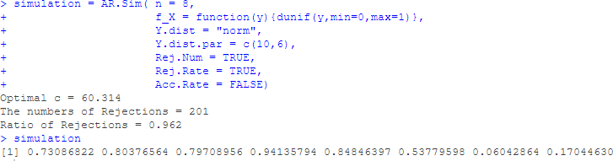

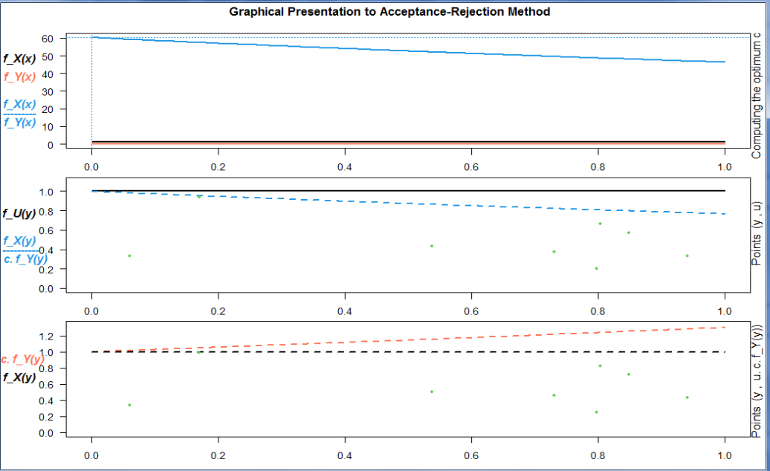

Inference: In this case, the rejection ration is 0.96 is significantly higher when sampling from Uniform distribution within the interval 0,1.
- Example: Write R Program to generate 8 observations using Acceptance-Rejection Algorithm for Uniform distribution in the interval (0,1) and Standard Normal Distribution and Comment on your result.
R Code with Output:
simulation = AR.Sim( n = 8,
f_X = function(y){dunif(y,min=0,max=1)}, Y.dist = "norm",
Y.dist.par = c(0,1), Rej.Num = TRUE, Rej.Rate = TRUE, Acc.Rate = FALSE)

simulation
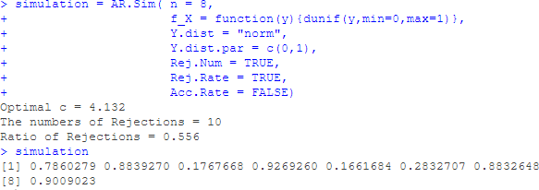

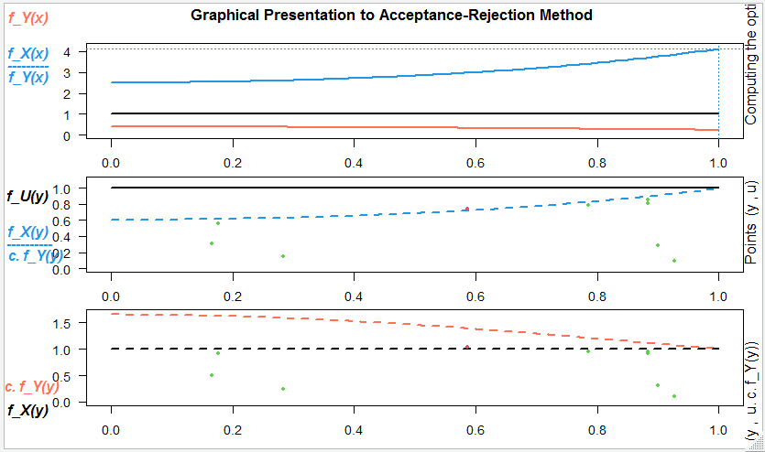

Inference: In this case, the rejection ration is 0.56 is not much significantly higher when sampling from Uniform distribution within the interval 0,1.

- Example: Write R Program to generate 5 observations using Acceptance-Rejection Algorithm for Uniform distribution in the interval (0,1) and Uniform distribution in the interval (0,1) and Comment on your result.
R Code with Output:
simulation = AR.Sim( n = 5,
f_X = function(y){dunif(y,min=0,max=1)}, Y.dist = "unif",
Y.dist.par = c(0,1), Rej.Num = TRUE, Rej.Rate = TRUE, Acc.Rate = FALSE)
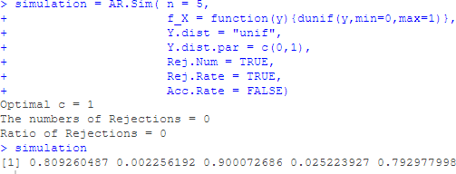

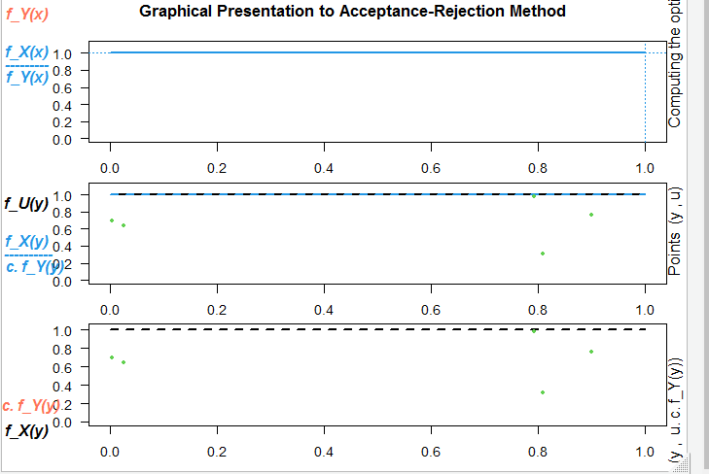

Inference: In this case, the rejection ration is 0. i.e generated random numbers are from same Uniform distribution. Hence all random numbers fall within the specified distribution

ViVa Questions
- Which package is used to generate random numbers in ‘R’language “ AR”
- The mean and Variance of Poisson distribution is --------- Mean=Variance=lamda
- The basic technique used to generate observations from a distribution is Rejection sampling

- Maximum likelihood and Method of moment’s estimation. Testing of Hypothesis based on Z-test. Concept of p-value in R
  - Maximum likelihood Estimation & Method of Moments estimation: R Code:
    - x=c(data vector)
>n=length(x) #No. of observations
>phat=mean(x)/n #MLE for Binomial distribution where n represents no.of independent trails in Binomial distribution
>lambdahat=mean(x) #MLE for Poisson distribution
>muhat=mean(x) #MLE of Mean for Normal distribution
>sigmahat=((n - 1)/n)*var(x) #MLE of variance for Normal distribution
Note: If the sample data is not given then generate the sample using random numbers of a particular distribution and then estimate the corresponding parameters.
R Code to generate the random numbers from Binomial, Poisson and Normal distribution
rbinom(no of random numbers to be generate, n, p) rpois(n,lambda)
rnorm(n, mean, sd)
- Example: Sample (9,2,5,3,1,5,2,4,2,1,3,5,6,1,1) is drawn from Binomial distribution. Use R program to find the maximum likelihood estimate of the parameter p and estimate the mean and variance.
R Code with Output:
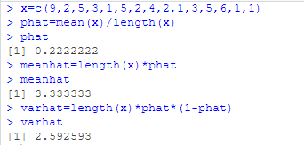

- Example: Let X follows Poisson distribution with parameter 12. Use R program to generate 10 samples from Poisson distribution and hence find the maximum likelihood estimate of the parameter and estimate the mean and variance.
R Code with Output:
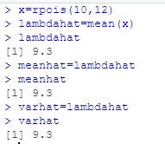

- Example: Sample (15, 9, 3, 7, 15, 8, 10, 3, 12, 5, 15, 8, 10, 3, 15, 8, 10, 3, 15, 8, 10, 3, 15, 7,
14, 10, 10, 14, 10, 9, 3, 3, 10, 15, 8, 10, 3, 15, 8, 10, 3, 12, 5, 15, 8, 10, 3, 15, 8, 10, 3) is drawn
from Normal distribution. Use R program to estimate the mean and variance using method of moments.
R Code with Output:

z=c(15,9,3,7,15,8,10,3,12,5,15,
8,10,3,15,8,10,3,15,8,10,3,
15,7,14,10,10,14,10,9,3,3,10,
15,8,10,3,15,8,10,3,12,5,15,
8,10,3,15,8,10,3)
muhat=mean(z) muhat
sigmahat=((51 - 1)/51)*var(z) sigmahat

muhat=mean(z)
- muhat
[1] 9.039216
- sigmahat=((51 - 1)/51)*var(z)
- sigmahat
[1] 17.3318

- Example: Sample (9, 3, 7, 12, 5, 15, 15, 8, 10, 3, 15, 7, 14, 10, 10, 14, 10, 9, 3, 3, 10) is drawn
from Poisson distribution. Use R program to estimate the parameter, mean and variance of Poisson using Method of Moments.
R Code with Output:

Y=c(9,3,7,12,5,15,15,8,10,3,15,7,14,10,10,14,10,9,3,3,10)
lambdahat=mean(Y) lambdahat
[1] 9.142857

meanhat=lambdahat meanhat
[1] 9.142857
varhat=lambdahat varhat

[1] 9.142857

  - Testing of Hypothesis (Large Samples)
    - Compute one sample proportion of z-test (Test for single proportion) R Code:
prop.test(x, n, p, alternative = "two.sided") prop.test(x, n, p, alternative = "less") prop.test(x, n,p, alternative = "greater")
x: the number of successes
n: the total number of trials
p: the probability to test against.
- Example: A manufacture of spark plugs claims that 3% of items supplied by him defective. A random sample of 500 plugs is found to have 20 defectives items. test the claim of manufacture. R Code with Output:
prop.test(20,500,0.03,alternative="two.sided")
prop.test(20,500,0.03,alternative="two.sided")
1-sample proportions test with continuity correction data: 20 out of 500, null probability 0.03
X-squared = 1.3918, df = 1, p-value = 0.2381 alternative hypothesis: true p is not equal to 0.03
95 percent confidence interval:
0.02524906 0.06216390
sample estimates: p
0.04
From the output we observe that:
Null Hypothesis (H0): p = 0.03 Alternative Hypothesis (H1): p ≠ 0.03
And the p value is 0.2381 > 0.05 level of significance Hence We Accept Null hypothesis
95 % Confidence interval is (0.0252, 0.0621)
Phat = 0.04
- Example: We have a population of mice containing half male and have female (p = 0.5 = 50%). Some of these mice (n = 160) have developed a spontaneous cancer, including 95 male and 65 female. Test whether the cancer affects more male than female?

R Code with Output: prop.test(95,160,0.5,alternative="greater") prop.test(95,160,0.5,alternative="greater")
  - sample proportions test with continuity correction

data: 95 out of 160, null probability 0.5
X-squared = 5.2562, df = 1, p-value = 0.01093 alternative hypothesis: true p is greater than 0.5
95 percent confidence interval:
0.5256923 1.0000000
sample estimates:
p 0.59375
From the output we observe that:
Null Hypothesis (H0): p = 0.5 Alternative Hypothesis (H1): p > 0.5
And the p value is 0.01093 < 0.05 level of significance (los) Hence We Reject Null hypothesis
95 % Confidence interval is (0.525, 1.0)
Phat = 0.593

- Compute two-proportions of z-test (Test for difference of proportions)

R Code:
prop.test(x=c(…..), n=c(……), p = NULL, alternative = " ")
- Example: In a large city A, consists of 900 school children, 20 had defective eyesight. In other large city B of a random sample 600 children, 15 had the same defect. Is this difference between the two proportions significant?
R Code with Output: prop.test(x=c(20,15),n=c(900,600),p=NULL,alternative="two.sided") prop.test(x=c(20,15),n=c(900,600),p=NULL,alternative="two.sided")
  - sample test for equality of proportions with continuity correction

data: c(20, 15) out of c(900, 600)
X-squared = 0.030473, df = 1, p-value = 0.8614 alternative hypothesis: two.sided
95 percent confidence interval:
-0.01994014 0.01438458
sample estimates: prop 1 prop 2
0.02222222 0.02500000

From the output we observe that: Null Hypothesis (H0): p1=p2

Alternative Hypothesis (H1): p1≠p2
And the p value is 0.8614 > 0.05 level of significance Hence We Accept Null hypothesis
95 % Confidence interval is (-0.019, 0.014) P1hat = 0.0222 P2hat=0.025
- Example: In a company 500 people are having lung cancer and 500 people are healthy individuals. The number of smokers in each group is 490 and 400. Test whether the proportions of smokers are the same in the two groups of individuals?
R Code with Output: prop.test(x=c(490,400),n=c(500,500),p=NULL,alternative="two.sided") prop.test(x=c(490,400),n=c(500,500),p=NULL,alternative="two.sided")
2-sample test for equality of proportions with continuity correction

data: c(490, 400) out of c(500, 500)
X-squared = 80.909, df = 1, p-value < 2.2e-16 alternative hypothesis: two.sided
95 percent confidence interval:
0.1408536 0.2191464
sample estimates:
prop 1 prop 2
0.98 0.80
From the output we observe that:
Null Hypothesis (H0): p1=p2 Alternative Hypothesis (H1): p1≠p2
And the p value is 2.2e-16 < 0.05 level of significance Hence We Reject Null hypothesis
95 % Confidence interval is (0.1408, 0.2191) P1hat = 0.98 P2hat=0.80
C. One sample Z test in R (Test for single mean) R Code:
install.packages("BSDA") #BSDA: Basic Statistics and Data Analysis
library(BSDA)
z.test(datavector, mu=population mean, sigma.x=………….., alternative= “………”)
1. Example: The price of a popular tennis racket at a national chain store is $179. Portia bought ten of the same racket at an online auction site for the following prices: 155,179,175,170,175,173,172,171,170,169,168,164,165,162,163,172,176,174,168,165,170,172,
168,162,175,161,160,158,156,171,170. If the auction prices of rackets are normally distributed, Use R code to determine whether there is sufficient evidence in the sample, at the 5% level of

significance, to conclude that the average price of the racket is less than $179 with standard deviation 6.1 if purchased at an online auction.
R Code with Output:
install.packages("BSDA") #BSDA: Basic Statistics and Data Analysis
library(BSDA) x=c(155,179,175,170,175,173,172,171,170,169,168,164,165,162,163,172,176,174,168,165,170,172,168,
162,175,161,160,158,156,171,170)
z.test(x,mu=179,sigma.x=6.1,alternative="less")
X
[1] 155 179 175 170 175 173 172 171 170 169 168 164 165 162 163 172 176 174
168 165 170
[22] 172 168 162 175 161 160 158 156 171 170
- z.test(X,mu=179,sigma.x=6.1,alternative="less")
One-sample z-Test

data: X
z = -10.011, p-value < 2.2e-16
alternative hypothesis: true mean is less than 179 sample estimates:
mean of x 168.0323
From the output we observe that:
Null Hypothesis (H0): µ=179 Alternative Hypothesis (H1): µ<179
And z = -10.011; the p value is 2.2e-16 < 0.05 level of significance Hence We Reject Null hypothesis
Meanhat=168.032
d.Two Sample Z-Test in R (Test for difference of means) R Code:
z.test(datavector1,datavector2, alternative=‘…………’, mu=0, sigma.x= ,
sigma.y= )
1. Example: Suppose the IQ levels among individuals in two different cities are known to be normally distributed each with population standard deviations of 15 and 12 respectively. A scientist wants to test whether the mean IQ level between individuals in city A and city B are different, so she selects a simple random sample of 32 from city A and 36 samples from city B and records their IQ levels.
[Hint: First generate random samples using rnorm]
R Code with Output:
cityA=rnorm(32,0,15) cityB=rnorm(36,0,12)
z.test(cityA,cityB,mu=0,sigma.x=15,sigma.y=12,alternative="two.sided")

cityA=rnorm(32,0,15) cityB=rnorm(36,0,12)
- z.test(cityA,cityB,mu=0,sigma.x=15,sigma.y=12,alternative="two.sided")
Two-sample z-Test data: cityA and cityB
z = 0.47479, p-value = 0.6349
alternative hypothesis: true difference in means is not equal to 0
95 percent confidence interval:
-4.932750 8.086635
sample estimates:
mean of x mean of y
-2.393633 -3.970575

From the output we observe that:
Null Hypothesis (H0): µ1= µ2 Alternative Hypothesis (H1): µ1≠ µ2
And z = 0.4747; the p value is 0.6349 >0.05 level of significance Hence We Accept Null hypothesis
95 % Confidence interval is (-4.9327, 8.0866)
Meanhat1= -2.3936 Meanhat2=-3.9705

Viva Questions:

- Define Null Hypothesis and Alternative Hypothesis.
Null Hypothesis (H0): A null hypothesis is the hypothesis which asserts that there is no significant difference between the sample and the population parameter.

Alternative Hypothesis (H1): Any hypothesis which contradicts the Null hypothesis is called Alternative hypothesis.
- Write the test statistic to test the difference of two proportions.

𝑧 =
𝑝₁ − 𝑝₂
~ (0,1)

1
√𝑃𝑄 (
𝑛₁
+ 1 )
𝑛₂

- Write the test-statistic to test for single mean in large samples.
𝑥̅− 𝜇
𝑧 = 𝜎 ~ (0,1)
√𝑛

- Testing of hypothesis based on t-test, chi-square test and F-test. Confidence interval estimation in R (Small Samples)
  - t test
- t-test for single mean R Code:
t.test(data vector, mu = population mean, alternative= “two.sided”, conf.level=0.98) t.test(data vector, mu = population mean, alternative= “less”)
t.test(data vector, mu = population mean, alternative= “greater”)
Note: Conf.level is an additional argument when one wants to construct 90% or 98% or 99%, we need to write. Otherwise by default it will construct 95% confidence interval without writing this additional argument.
- Example: A random sample of 10 envelopes is taken from the letter box of a post office and their weights in grams are found to be 13.1, 14.5, 12.1, 11.9, 12.4, 12.3, 11.5, 11.6, 12.1 and
12.4. Does this sample indicate at 1% level that the average weight of envelopes received at their post office is 12.35 grams? Also construct 99% confidence interval for population mean.
R Code with Output:
A=c(13.1,14.5,12.1,11.9,12.4,12.3,11.5,11.6,12.1,12.4)
t.test(A,mu=12.35,alternative="two.sided", conf.level = 0.99) A=c(13.1,14.5,12.1,11.9,12.4,12.3,11.5,11.6,12.1,12.4)
  - t.test(A,mu=12.35,alternative="two.sided", conf.level = 0.99)
One Sample t-test

data: A
t = 0.14564, df = 9, p-value = 0.8874
alternative hypothesis: true mean is not equal to 12.35
99 percent confidence interval:
11.49743 13.28257
sample estimates:
mean of x
12.39
From the output we observe that:
Null Hypothesis (H0): µ1= 12.35 Alternative Hypothesis (H1): µ1≠ 12.35
And t = 0.14564; the p value is 0.8874> 0.01 level of significance
Hence We do not Reject Null hypothesis. 99 % Confidence interval is
(11.4974, 13.2825)
mean of x
12.39

- Example: Test the hypothesis that the average content of containers of a particular lubricant is 10 liters if the content of a random sample of 10 containers are:
10.2, 9.7, 10.1, 10.3, 10.1, 9.8, 9.9, 10.4, 10.3, 9.8
Use 0.01 l.o.s and assume that the distribution of contents is normal. Also construct 95% confidence interval for population mean.
R Code with Output:
x=c(10.2, 9.7, 10.1, 10.3, 10.1, 9.8, 9.9, 10.4, 10.3, 9.8)
t.test(x,mu=10,alternative="two.sided")
x=c(10.2, 9.7, 10.1, 10.3, 10.1, 9.8, 9.9, 10.4, 10.3, 9.8)
- t.test(x,mu=10,alternative="two.sided")
One Sample t-test

data: x
t = 0.77174, df = 9, p-value = 0.46
alternative hypothesis: true mean is not equal to 10
95 percent confidence interval: 9.884126 10.235874
sample estimates:
mean of x
10.06

From the output we observe that:
Null Hypothesis (H0): µ1= 10 Alternative Hypothesis (H1): µ1≠ 10
And t = 0.771; the p value is 0.46 > 0.05 level of significance Hence We Accept Null hypothesis
95 % Confidence interval is (9.884, 10.235)
Meanhat= 10.06
- Two sample t test (Test for difference of means_independent samples)

R Code:
t.test(data vector 1, data vector 2, mu = 0, alternative= “ ”)
1. Example: Two Horses A and B were tested according to the time (seconds) in a particular track with the following results.

Horse A | 28 | 30 | 32 | 33 | 33 | 29 | 34
Horse B | 29 | 30 | 30 | 24 | 27 | 29 | -
Test whether the two horses have same running capacity? Also construct 95% confidence interval for population mean.

R Code with Output:
HorseA=c(28,30,32,33,33,29,34) HorseB=c(29,30,30,24,27,29)
t.test(HorseA,HorseB,mu=0,alternative="two.sided")
t.test(HorseA,HorseB,mu=0,alternative="two.sided")
Welch Two Sample t-test data: HorseA and HorseB
t = 2.4335, df = 10.652, p-value = 0.03386
alternative hypothesis: true difference in means is not equal to 0
95 percent confidence interval:
0.2867853 5.9513100
sample estimates:
mean of x mean of y 31.28571 28.16667
From the output we observe that:
Null Hypothesis (H0): µ1= µ2 Alternative Hypothesis (H1): µ1≠ µ2
And t = 2.4335; the p value is 0.033 < 0.05 level of significance Hence, We Reject Null hypothesis
95 % Confidence interval is (0.286, 5.951)
Meanhatx= 31.285 Meanhaty= 28.166

- Paired t test (Test for difference of means_dependent samples) R Code:
t.test(after, before, paired = TRUE, alternative = "………")
1. Example: Memory capacity of 10 students was tested before and after training. Test whether the training was effective or not from the following scores. Also construct 99% confidence interval for population mean.

Before training | 12 | 14 | 11 | 8 | 7 | 10 | 3 | 0 | 5 | 6
After training | 15 | 16 | 10 | 7 | 5 | 12 | 10 | 2 | 3 | 8

R Code with Output: before=c(12,14,11,8,7,10,3,0,5,6)
after=c(15,16,10,7,5,12,10,2,3,8)
t.test(before,after,paired=TRUE,alternative="two.sided")

Paired t-test
data: before and after
t = -1.3646, df = 9, p-value = 0.2055
alternative hypothesis: true mean difference is not equal to 0
95 percent confidence interval:
-3.1893268 0.7893268
sample estimates:
mean difference
-1.2
From the output we observe that:
Null Hypothesis (H0): µ1= µ2 Alternative Hypothesis (H1): µ1≠ µ2
And t = -1.3646; the p value is 0.2055 > 0.05 level of significance Hence, We Accept Null hypothesis
95 % Confidence interval is (-3.189, 0.789)
Meandifference = -1.2
  - Chi-square test R Code:
x=matrix(c(data),ncol= ,nrow=……,byrow=TRUE)
or
x =data.frame(col1 = c (…..), col2 = c(…..), )
x chisq.test(x)
1. Example: 1000 students at college level were graded according to their I.Q and the economic conditions of their home. Write R code to test whether there is any association between condition at home and I.Q.
 | I.Q
Economic | High | Low | Total
Rich | 460 | 140 | 600
Poor | 240 | 160 | 400
Total | 700 | 300 | 1000

R Code with Output:
x=matrix(c(460,140,240,160),ncol=2,nrow=2,byrow=TRUE) x
chisq.test(x)
x=matrix(c(460,140,240,160),ncol=2,nrow=2,byrow=TRUE)
- x
[,1] [,2]
[1,] 460 140
[2,] 240 160
- chisq.test(x)
Pearson's Chi-squared test with Yates' continuity correction data: x
X-squared = 30.957, df = 1, p-value = 2.638e-08

From the output we observe that:
Null Hypothesis (H0): Two attributes are independent Alternative Hypothesis (H1): Two attributes are not independent
And chi-square = 30.957; the p value is 0.0000 < 0.05 level of significance Hence, We Reject Null hypothesis
Example: In an industry, 1000 workers, employed for a specific job, were classified according to their performance and training received to test independence of a specific training and performance. The data is summarized as follows.
Training | Performance
Training | Good | Not Good
Trained | 230 | 148
Untrained | 151 | 471
Write R code to make use of Chi-square test for independence at 5 % level of significance and write your conclusion.
R Code with Output:
x=matrix(c(230,148,151,471),ncol=2,nrow=2,byrow=TRUE) x
x
[,1] [,2]
[1,] 230 148
[2,] 151 471
chisq.test(x) chisq.test(x)
Pearson's Chi-squared test with Yates' continuity correction
data: x
X-squared = 131.78, df = 1, p-value < 2.2e-16
From the output we observe that:
Null Hypothesis (H0): Two attributes specific training and performance are independent Alternative Hypothesis (H1): Two attributes specific training and performance are not independent
And chi-square = 131.78; the p value is 2.2e-16< 0.05 level of significance Hence, We Reject Null hypothesis.

  - F-test. (Test for equality of variances) R Code:
var.test(sample1,sample2,alternative=”….”)
Note: While calculating F ratio, F value should be greater than 1. If not interchange the samples.
- Example: Two Horses A and B were tested according to the time (seconds) in a particular track with the following results.
Horse A | 28 | 30 | 32 | 33 | 33 | 29 | 34
Horse B | 29 | 30 | 30 | 24 | 27 | 29 | -
Test at 5% level whether the populations have the same variance.
R Code with Output:
x=c(28,30,32,33,33,29,34)
y=c(29,30,30,24,27,29)
var.test(y,x,alternative="two.sided")
var.test(y,x,alternative="two.sided")
F test to compare two variances data: y and x
F = 1.0245, num df = 5, denom df = 6, p-value = 0.9573 alternative hypothesis: true ratio of variances is not equal to 1
95 percent confidence interval:
0.1711122 7.1489727
sample estimates:
ratio of variances
1.024545

From the output we observe that:
Null Hypothesis (H0): σ ²= σ ²
1 2
Alternative Hypothesis (H1): σ ² ≠ σ ²
1 2
And F = 1.0245; the p value is 0.9573 > 0.05 level of significance Hence, We Accept Null hypothesis
95 % Confidence interval is (0.1711, 7.148)

- Example: The following are the values in thousands of an inch obtained by 2 engineers in 8 successive measurements with the same micrometer:
Engineer A: 503,505,497,505,419,493,510,501
Engineer B: 502,497,492,490,495,497,596,498
Is one engineer more consistent than the other?

R Code with Output:
x=c(503,505,497,505,419,493,510,501) y=c(502,497,492,490,495,497,596,498)
var.test(y,x,alternative="two.sided")
F test to compare two variances

data: y and x
F = 1.4265, num df = 7, denom df = 7, p-value = 0.651 alternative hypothesis: true ratio of variances is not equal to 1
95 percent confidence interval:
0.2855932 7.1252993
sample estimates:
ratio of variances
1.426512

From the output we observe that:
Null Hypothesis (H0): σ12= σ22 Alternative Hypothesis (H1): σ12 ≠ σ22
And F = 1.4265; the p value is 0.651 > 0.05 level of significance Hence, We Accept Null hypothesis
95 % Confidence interval is (0.285, 7.125)

- Multiple linear regression: Outlier analysis, residual analysis, test for normality, multi collinearity in R
6.1 Fitting of Multiple Linear Regression R Code:  MLR<- lm(Dependent variable ~ sum of independent variables) | - Testing MLR R Code: summary(MLR)
6.2. Outlier analysis R Code: plot(MLR) | 6.3. Residual analysis R Code  Residuals=resid(MLR) Predicted=predict(MLR) Residuals  Predicted plot(Residuals,Predicted)
6.4. Test for normality R Code:  plot(MLR,2)  # 2 indicates second plot i.e Normal Q-Q plot  shapiro.test(Residuals)  # to test the Residuals follows normality or not | 6.5. Multi Collinearity R Code:  install.packages("caTools")  # For Linear regression  install.packages('car')  # To check multicollinearity install.packages("quantmod") install.packages("MASS") install.packages("corrplot")  # plot correlation plot  library(caTools) library(car) library(quantmod) library(MASS) library(corrplot)  vif(MLR) #Variance Inflation Factor (vif) specifies whether Multicollinearity present in the variables or not  if vif value is >10 then there exist Multicollinearity

- Example:
The diameter of a tree at its breast height is influenced by many factors. The below table relate the diameter of a particular type of eucalyptus tree to its age, average rainfall at its site, site’s elevation, and the wood’s mean specific gravity.
S.No. | Age (Years) | Elevation (1000 ft) | Rainfall (inches) | Specific Gravity | Diameter at Breast Height (inches)
1 | 35 | 1.5 | 110 | 0.63 | 18.1
2 | 36 | 1.2 | 115 | 0.59 | 19.6
3 | 34 | 2.1 | 80 | 0.56 | 16.6
4 | 35 | 2.3 | 89 | 0.55 | 16.4
5 | 36 | 2.5 | 78 | 0.54 | 16.9
6 | 32 | 1.6 | 54 | 0.59 | 17.0
7 | 35 | 1.5 | 86 | 0.56 | 20.0
8 | 38 | 1.4 | 110 | 0.46 | 16.6
9 | 39 | 2.3 | 118 | 0.63 | 16.2
10 | 34 | 2.5 | 119 | 0.60 | 18.5
11 | 32 | 2.6 | 200 | 0.63 | 18.7
12 | 31 | 1.2 | 240 | 0.58 | 19.4
13 | 35 | 1.3 | 210 | 0.55 | 17.6
14 | 36 | 1.8 | 110 | 0.57 | 18.3
15 | 32 | 1.9 | 118 | 0.62 | 18.8

- Fit a Multiple linear regression model and Test the Model
- Identify the Outliers in the data
- Check for Multicollinearity for the variables
- Compute the Residuals
- Test for Normality
- R Code with Output:
Age=c(35,36,34,35,36,32,35,38,39,34,32,31,35,36,32) Elevation=c(1.5,1.2,2.1,2.3,2.5,1.6,1.5,1.4,2.3,2.5,2.6,1.2,1.3,1.8,1.9) Rainfall=c(110,115,80,89,78,54,86,110,118,119,200,240,210,110,118) Diameter=c(18.1,19.6,16.6,16.4,16.9,17,20,16.6,16.2,18.5,18.7,19.4,17.6,18.3,18.8)
Gravity=c(0.63,.59,.56,.55,.54,.59,.56,.46,.63,.60,.63,.58,.55,.57,.62)
MLR=lm(Diameter~Age+Elevation+Rainfall+Gravity) summary(MLR)

Call:
lm(formula = Diameter ~ Age + Elevation + Rainfall + Gravity)

Residuals:
Min 1Q Median 3Q Max
-1.4357 -0.7493 -0.1480 0.5501 2.0489

Coefficients:
Estimate Std. Error t value Pr(>|t|)
(Intercept) 19.546563 7.820128 2.500 0.0315 *
Age | -0.146790 0.150096 | -0.978 0.3512
Elevation | -1.038764 0.644716 | -1.611 0.1382
Rainfall | 0.003418 0.006245 | 0.547 0.5961
Gravity | 8.582746 7.548318 | 1.137 0.2820
---
Signif. codes: 0 ‘***’ 0.001 ‘**’ 0.01 ‘*’ 0.05 ‘.’ 0.1 ‘ ’ 1

Residual standard error: 1.126 on 10 degrees of freedom Multiple R-squared: 0.4233, Adjusted R-squared: 0.1927
F-statistic: 1.835 on 4 and 10 DF, p-value: 0.1987

Inference:
The Independent variables are not significant here because the corresponding p-values are greater than 0.05, so they cannot explain the variation in the dependent variable. i.e to explain variation in dependent variable ( diameter of breast of tree )these independent variables are not sufficient, may be some other variables will be significant.

- R Code with Output:

plot(MLR)

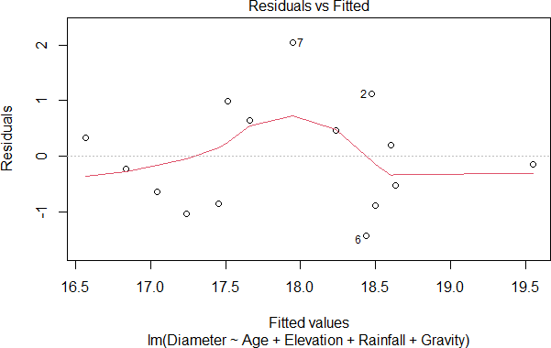

Inference: From the above graph 6,7,20 are outliers

- R Code with Output:

install.packages("caTools") # For Linear regression install.packages('car') # To check multicollinearity install.packages("quantmod") install.packages("MASS") install.packages("corrplot") # plot correlation plot library(caTools)
library(car) library(quantmod) library(MASS) library(corrplot) vif(MLR)
vif(MLR)
Age Elevation Rainfall Gravity 1.268037 1.160155 1.199486 1.272002
Inference:
No factor is having >10. Hence there is no multicollinearity

- R Code with Output:
Residuals=resid(MLR) Predicted=predict(MLR) Residuals
Predicted plot(Residuals,Predicted)
Residuals=resid(MLR)
- Predicted=predict(MLR)
- Residuals Residuals=resid(MLR)
- Predicted=predict(MLR)
- Residuals
1 | 2 | 3 | 4 | 5 | 6 | 7
-0.5339163 | 1.1274623 | -0.8541022 | -0.6444976 | 0.3334760 | -1.4356677 | 2.0489187
8
-0.2383551
9 | 10 | 11 | 12 | 13 | 14 | 15
-1.0430912 | 0.9847743 | 0.4606936 | -0.1479675 | -0.8968942 | 0.6394681 | 0.1996987

- Predicted  1 |  | 2 | 3 | 4 | 5 | 6 | 7 | 8
9
18.63392 | 18.47254 |  | 17.45410 | 17.04450 | 16.56652 | 18.43567 | 17.95108 | 16.83836 | 17.24
309
10 |  | 11 | 12 | 13 | 14 | 15
17.51523 | 18.23931 |  | 19.54797 | 18.49689 | 17.66053 | 18.60030
Plot(Residuals,predicted) plot(Residuals,Predicted)

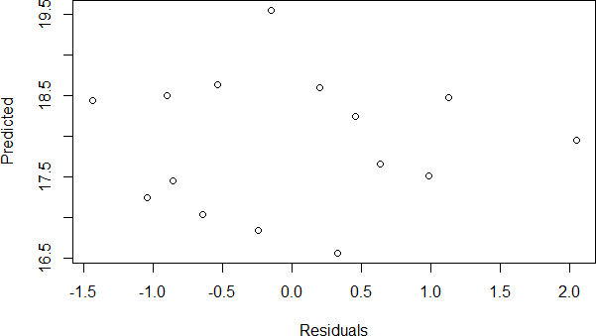

- R Code with Output:

plot(MLR,2)

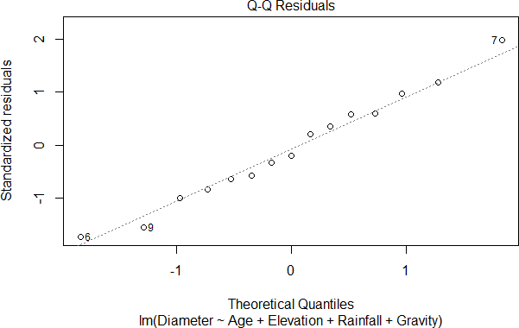

shapiro.test(Residuals)
shapiro.test(Residuals)
Shapiro-Wilk normality test data: Residuals
W = 0.97048, p-value = 0.8652
H0 :The Residuals are normally distributed
H1 :The Residuals are not Normally distributed
Inference: If p-value = 0.8652 > 0.05 Accept H0.
- Example: The data given below consists of 10 observations on the response (Y) effected by the independent variables X1, X2, X3, X4. Use R code:
  - Fit a Multiple linear regression model
  - Identify the Outliers in the data
  - Test for Normality
Y | 21.0 | 22.0 | 21.0 | 23.0 | 21.2 | 23.2 | 21.5 | 22.0 | 22.3 | 22.5
X1 | 2.3 | 2.5 | 2.6 | 2.5 | 2.4 | 2.1 | 2.0 | 2.2 | 2.3 | 2.9
X2 | 3.1 | 3.2 | 3.3 | 3.4 | 3.5 | 3.6 | 3.8 | 3.9 | 3.2 | 3.3
X3 | 4.1 | 4.2 | 4.3 | 4.4 | 4.5 | 4.6 | 4.6 | 4.8 | 4.9 | 4.2
X4 | 5 | 6 | 7 | 8 | 9 | 1 | 5 | 4 | 2 | 6

- R Code with Output:
Y=c(21.0,22.0,21.0,23.0,21.2,23.2,21.5,22.0,22.3,22.5)
X1=c(2.3,2.5,2.6,2.5,2.4,2.1,2.0,2.2,2.3,2.9)
X2=c(3.1,3.2,3.3,3.4,3.5,3.6,3.8,3.9,3.2,3.3)
X3=c( 4.1,4.2,4.3,4.4,4.5,4.6,4.6,4.8,4.9,4.2) X4=c(5,6,7,8,9,1,5,4,2,6) mlr=lm(Y~X1+X2+X3+X4)
summary(mlr)
Call:
lm(formula = Y ~ X1 + X2 + X3 + X4) Coefficients:
Estimate Std. Error t value Pr(>|t|) (Intercept) 13.7806 8.9768 1.535 0.185
X1 | 1.7994 | 1.5884 | 1.133 0.309
X2 | 0.8885 | 1.5039 | 0.591 0.580
X3 | 0.4200 | 1.5674 | 0.268 0.799
X4 | -0.1913 | 0.1514 | -1.264 0.262

Residual standard error: 0.8618 on 5 degrees of freedom Multiple R-squared: 0.344, Adjusted R-squared: -0.1808
F-statistic: 0.6555 on 4 and 5 DF, p-value: 0.6483
Inference:

The Independent variables are not significant here because the corresponding p-values are greater than 0.05, so they cannot explain the variation in the dependent variable y.

- R Code with Output:

plot(mlr)

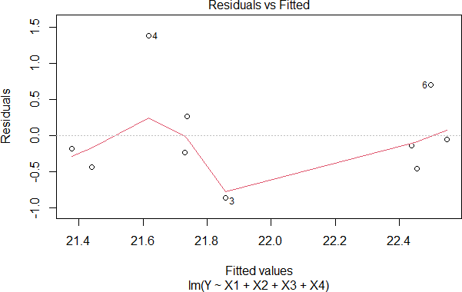
Inference: From the above graph 3,4,60 are outliers
C) R Code with Output:
plot(mlr,2)

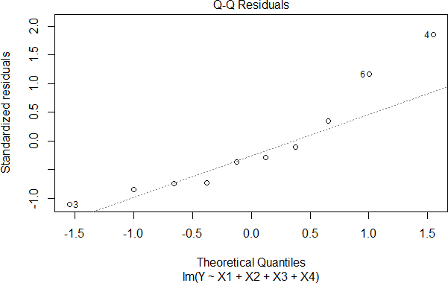
shapiro.test(Residuals)
shapiro.test(Residuals)
Shapiro-Wilk normality test data: Residuals
W = 0.91186, p-value = 0.294
H0 :The Residuals are normally distributed
H1 :The Residuals are not Normally distributed
Inference: If p-value = 0.294> 0.05 Accept H0.

- Fit Multiple Linear regression to Marketing data which is available in “R”.
  - Identify the Outliers in the data
  - Test for Normality
Note: This data can be downloaded using the package "datarium"

R Code with Output:

data("marketing", package = "datarium") head(marketing, 4) #Displays first 4 values in the data
head(marketing, 4)
youtube facebook newspaper sales
1 276.12 45.36 83.04 26.52
2 53.40 47.16 54.12 12.48
3 20.64 55.08 83.16 11.16
4 181.80 49.56 70.20 22.20

tail(marketing) #Displays last 6 values in the data
youtube facebook newspaper sales

195 179.64 | 42.72 | 7.20 | 20.76
196 45.84 | 4.44 | 16.56 | 9.12
197 113.04 | 5.88 | 9.72 | 11.64
198 212.40 | 11.16 | 7.68 | 15.36
199 340.32 | 50.40 | 79.44 | 30.60
200 278.52 | 10.32 | 10.44 | 16.08

View(marketing) #Displays the total data
model <- lm(sales ~ youtube + facebook + newspaper, data = marketing) summary(model)
model <- lm(sales ~ youtube + facebook + newspaper, data = marketing)
- summary(model)

Call:
lm(formula = sales ~ youtube + facebook + newspaper, data = marketing)
Residuals:
Min 1Q Median 3Q Max
-10.5932 -1.0690 0.2902 1.4272 3.3951
Coefficients:
Estimate Std. Error t value Pr(>|t|)
(Intercept) 3.526667 0.374290 9.422 <2e-16 ***
youtube 0.045765 0.001395 32.809 <2e-16 ***
facebook 0.188530 0.008611 21.893 <2e-16 ***
newspaper -0.001037 0.005871 -0.177 0.86
---
Signif. codes: 0 ‘***’ 0.001 ‘**’ 0.01 ‘*’ 0.05 ‘.’ 0.1 ‘ ’ 1
Residual standard error: 2.023 on 196 degrees of freedom Multiple R-squared: 0.8972, Adjusted R-squared: 0.8956 F-statistic: 570.3 on 3 and 196 DF, p-value: < 2.2e-16

INFERENCE:
The p-values regarding intercept, YouTube and Facebook, are less than 0.05. So these variables are significant and also included in the model.
The model equation is sales =3.52667 +0.0457 *YouTube+0.1885*Facebook

Multiple R-square and Adjusted R-square are approximately equal for the above data. Adjusted R-square value is 0.89565.So the independent variables YouTube and Facebook explains 89 % variation in the dependent variable sales which plays major role.
  - If one or more independent variables added to the model, then Multiple R Square value will increase whether it is significant or not and Adjusted R squared value either will decrease or constant in the case insignificant.
  - If Adjusted R squared value increases then the added independent variable is significant and the variable will be included in the model.

F –test is used to test the overall significant of the model H0: The model is not significant
H1: The model is significant
The p-value for this f-statistic is less than 0.05 so we reject H0.Therefore the model is significant to the data.

- R Code with Output:

plot(model)

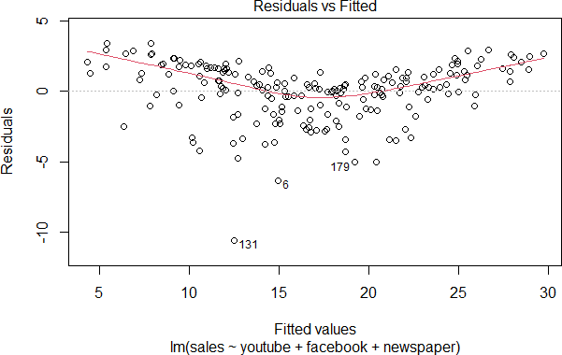

Inference: From the above graph 6,131,179 are outliers.

- R Code with Output:
plot(model,2)

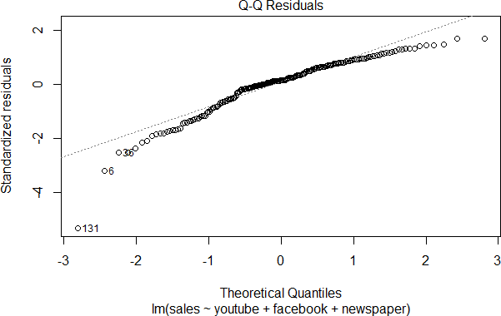

Shapiro-Wilk normality test data: Residuals
W = 0.97048, p-value = 0.8652
H0 :The Residuals are normally distributed
H1 :The Residuals are not Normally distributed
Inference: If p-value = 0.8652> 0.05
Accept H0.

Viva Questions

  - Define Linear Regression.
It is the mathematical average relationship between dependent and independent variables
  - Define Residual.
Difference between actual response variable and predicted response variable
  - Define Multicollinearity and when Multicollinearity exist in linear regression. Multicollinearity occurs when two or more independent variables in a data frame have a
high correlation with one another in a regression model.Multicollinearity
exists whenever an independent variable is highly correlated with one or more of the other independent variables in a multiple regression equation..

- Logistic Regression in R R Code:
Logistic_Reg = glm(Dependent variable ~ sum of Independent variables, family="binomial")
summary(Logistic_Reg)
- Example:
Consider data published on n = 27 leukemia patients. The data has a response variable of whether leukemia remission occurred (REMISS), which is given by a 1. The predictor variables are cellularity of the marrow clot section (CELL), smear differential percentage of blasts (SMEAR), percentage of absolute marrow leukemia cell infiltrate (INFIL), percentage labeling index of the bone marrow leukemia cells (LI), absolute number of blasts in the peripheral blood (BLAST), and the highest temperature prior to start of treatment (TEMP).
REMISS | CELL | SMEAR | INFIL | LI | BLAST | TEMP
1 | 0.8 | 0.83 | 0.66 | 1.9 | 1.1 | 1
1 | 0.9 | 0.36 | 0.32 | 1.4 | 0.74 | 0.99
0 | 0.8 | 0.88 | 0.7 | 0.8 | 0.18 | 0.98
0 | 1 | 0.87 | 0.87 | 0.7 | 1.05 | 0.99
1 | 0.9 | 0.75 | 0.68 | 1.3 | 0.52 | 0.98
0 | 1 | 0.65 | 0.65 | 0.6 | 0.52 | 0.98
1 | 0.95 | 0.97 | 0.92 | 1 | 1.23 | 0.99
0 | 0.95 | 0.87 | 0.83 | 1.9 | 1.35 | 1.02
0 | 1 | 0.45 | 0.45 | 0.8 | 0.32 | 1
0 | 0.95 | 0.36 | 0.34 | 0.5 | 0 | 1.04
0 | 0.85 | 0.39 | 0.33 | 0.7 | 0.28 | 0.99
0 | 0.7 | 0.76 | 0.53 | 1.2 | 0.15 | 0.98
0 | 0.8 | 0.46 | 0.37 | 0.4 | 0.38 | 1.01
0 | 0.2 | 0.39 | 0.08 | 0.8 | 0.11 | 0.99
0 | 1 | 0.9 | 0.9 | 1.1 | 1.04 | 0.99
1 | 1 | 0.84 | 0.84 | 1.9 | 2.06 | 1.02
0 | 0.65 | 0.42 | 0.27 | 0.5 | 0.11 | 1.01
0 | 1 | 0.75 | 0.75 | 1 | 1.32 | 1
0 | 0.5 | 0.44 | 0.22 | 0.6 | 0.11 | 0.99
1 | 1 | 0.63 | 0.63 | 1.1 | 1.07 | 0.99
0 | 1 | 0.33 | 0.33 | 0.4 | 0.18 | 1.01
0 | 0.9 | 0.93 | 0.84 | 0.6 | 1.59 | 1.02
1 | 1 | 0.58 | 0.58 | 1 | 0.53 | 1
0 | 0.95 | 0.32 | 0.3 | 1.6 | 0.89 | 0.99
1 | 1 | 0.6 | 0.6 | 1.7 | 0.96 | 0.99
1 | 1 | 0.69 | 0.69 | 0.9 | 0.4 | 0.99
0 | 1 | 0.73 | 0.73 | 0.7 | 0.4 | 0.99

R Code with Output: Remiss=c(1,1,0,0,1,0,1,0,0,0,0,0,0,0,0,1,0,0,0,1,0,0,1,0,1,1,0) cell=c(.8,.9,.8,1,.9,1,.95,.95,1,.95,.85,.7,.8,.2,1,1,.65,1,.5,1,1,.9,1,.95,1,1,1)
smear=c(.83,.36,.88,.87,.75,.65,.97,.87,.45,.36,.39,.76,.46,.39,.9,.84,.42,.75,.44,.63,.33,.93,.58,.3 2,.6,.69,.73)
infil=c(.66,.32,.7,.89,.68,.65,.92,.83,.45,.34,.33,.53,.37,.08,.9,.84,.27,.75,.22,.63,.33,.84,.58,.3,.6,. 69,.73)
l1=c(1.9,1.4,0.8,.7,1.3,.6,1,1.9,.8,.5,.7,1.2,.4,.8,1.1,1.9,.5,1,.6,1.1,.4,.6,1,1.6,1.7,0.9,0.7)
blast=c(1.1,.74,.18,1.05,0.52,0.52,1.23,1.35,0.32,0,0.28,0.15,0.38,0.11,1.04,2.06,0.11,1.32,0.11, 1.07,0.18,1.59,0.53,0.89,0.96,0.4,0.4)
temp=c(1,.99,.98,.99,.98,.99,.99,1.02,1,1.04,0.99,.98,1.01,.99,.99,1.02,1.01,1,.99,.99,1.01,1.02,1
,.99,.99,.99,.99)
logistic_Model=glm(Remiss~cell+smear+infil+l1+blast+temp,family="binomial") logistic_Model
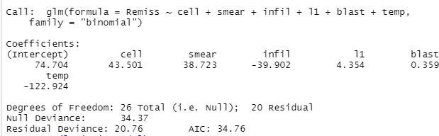

Inference:
𝑅̂𝑒𝑚𝚤𝑠𝑠 = 74.704 + 43.501 ∗ 𝑐𝑒𝑙𝑙 + 38.723 ∗ 𝑠𝑚𝑒𝑎𝑟 − 39.902 ∗ 𝑖𝑛𝑓𝑖𝑙 + 4.354 ∗ 𝑙1 + 0.359
∗ 𝑏𝑙𝑎𝑠𝑡 − 122.924 ∗ 𝑡𝑒𝑚𝑝

summary(logistic_Model)
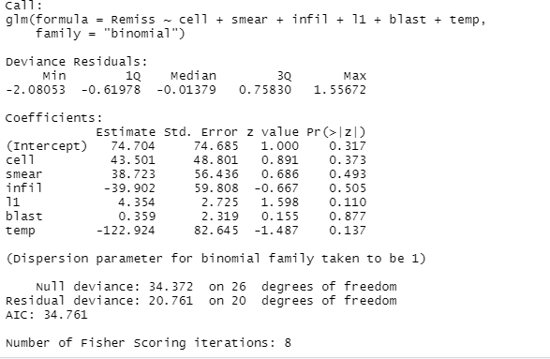
Inference:
All the p- values corresponding to coefficients are greater than 0.05,so these variables are not significant.

- Fit Logistic Regression to Student admit data and write the appropriate results Note: The data can be download using the following code
install.packages("packagename")
mydata <- read.csv("https://stats.idre.ucla.edu/stat/data/binary.csv")

R Code with Output:
install.packages("packagename")

mydata <- read.csv("https://stats.idre.ucla.edu/stat/data/binary.csv")
- View(mydata)
- summary(mydata)#Displays Min,1stquartile,median,mean,3rd quartile,max for all variables
admit | gre | gpa | rank
Min. :0.0000 | Min. :220.0 | Min. :2.260 | Min. :1.000
1st Qu.:0.0000 | 1st Qu.:520.0 | 1st Qu.:3.130 | 1st Qu.:2.000
Median :0.0000 | Median :580.0 | Median :3.395 | Median :2.000
Mean :0.3175 | Mean :587.7 | Mean :3.390 | Mean :2.485
3rd Qu.:1.0000 | 3rd Qu.:660.0 | 3rd Qu.:3.670 | 3rd Qu.:3.000
Max. :1.0000 | Max. :800.0 | Max. :4.000 | Max. :4.000

- str(mydata) #Displays the Structure of the data

‘data.frame': | 400 obs. of | 4 variables:
$ admit: int | 0 1 1 1 0 1 | 1 0 1 0 ...
$ gre : int | 380 660 800 | 640 520 760 560 400 540 700 ...
$ gpa : num | 3.61 3.67 4 | 3.19 2.93 3 2.98 3.08 3.39 3.92 ...
$ rank : int 3 3 1 4 4 2 1 2 3 2 ...
- mydata$rank <- factor(mydata$rank) mydata$admit<-factor(mydata$admit)
- mylogit <- glm(admit ~ gre + gpa + rank, data = mydata, family = "binomial"
)
- summary(mylogit)
Call:
glm(formula = admit ~ gre + gpa + rank, family = "binomial", data = mydata)
Coefficients:
 | Estimate | Std. Error | z value | Pr(>|z|)
(Intercept) | -3.989979 | 1.139951 | -3.500 | 0.000465 ***
Gre | 0.002264 | 0.001094 | 2.070 | 0.038465 *
Gpa | 0.804038 | 0.331819 | 2.423 | 0.015388 *
rank2 | -0.675443 | 0.316490 | -2.134 | 0.032829 *
rank3 | -1.340204 | 0.345306 | -3.881 | 0.000104 ***
rank4  --- | -1.551464 | 0.417832 | -3.713 | 0.000205 ***
Signif. codes: 0 ‘***’ 0.001 ‘**’ 0.01 ‘*’ 0.05 ‘.’ 0.1 ‘ ’ 1 (Dispersion parameter for binomial family taken to be 1)
Null deviance: 499.98 on 399 degrees of freedom Residual deviance: 458.52 on 394 degrees of freedom AIC: 470.52

Number of Fisher Scoring iterations: 4

INFERENCE
All the p-values corresponding to intercept,gre,gpa and rank in this model output are significant and also these are included in the model.
The logistic model equation is
Y= -3.989979 +0.002264 *gre + 0.804038 *gpa -0.675443 *rank2-1.340204 *rank3
-1.551464*rank4
The probability values will be calculated by using the following equation
Here P = e^{y}/ 1+ e^{y} # this helps to convert continuous values in to categorical values by considering p>0.5 as 1 and P<0.5 as 0

Note:Logistic Regression is a classification technique , it s called as logistic regression because, in out put it gives continuous vales.

Viva Questions:
- What kind of Machine Learning is Logistic Regression? Supervised Machine Learning

- Define Binary Response Variable?
A binary response variable is a categorical variable that can only take one of two values

- State any two differences of Linear Regression and Logistic Regression?

Linear regression is used to predict the  continuous dependent variable using a given set of independent variables. | Logistic Regression is used to predict the  categorical dependent variable using a given set of independent variables.
Linear Regression is used for solving  Regression problem. | Logistic regression is used for solving  Classification problems.

- Classification with SVM in R R Code:
install.packages("e1071")
library(e1071)
x = matrix(rnorm(32), 16, 2) #Generating the data
y = rep(c(-1, 1), c(8, 8)) #Assigning +1 and -1 to the above data
x[y == 1,] = x[y == 1,] + 1 #bias the x variable when y =1
dat = data.frame(x, y = as.factor(y)) #representing the above data in table form using dataframe
svm = svm(y ~ ., data = dat, kernel = "linear",cost=10) summary(svm)
- Example: Write R code to find the number of support vectors for classifying the data. Data as follows: 60 observations, in two columns and also get the SVM classification plot.
R Code with Output:
install.packages("e1071") library(e1071)
x = matrix(rnorm(60), 30, 2)
y = rep(c(-1, 1), c(15, 15))
x[y == 1,] = x[y == 1,] + 1
data = data.frame(x, y = as.factor(y))
svm = svm(y ~ ., data = data, kernel = "linear",cost=10) summary(svm)
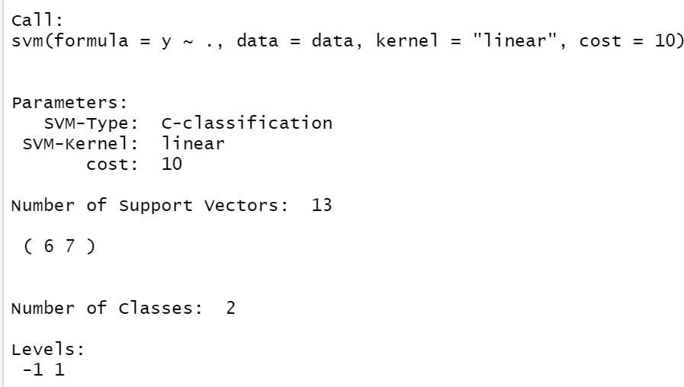

Inference: From the above output there were 13 support vectors, 6 in one class and 7 in another class.

plot(svm,data)

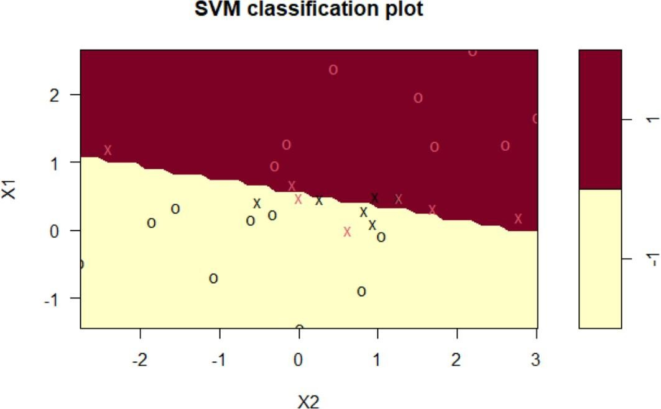

Inference: The support vectors as crosses and the remaining observations are plotted as circles.

- Example: Write R code to find the number of support vectors for classifying the data. Data as follows: 100 observations, in two columns and also get the SVM classification plot.
R Code with Output:
x = matrix(rnorm(100), 50, 2)
y = rep(c(-1, 1), c(25, 25))
x[y == 1,] = x[y == 1,] + 1
data = data.frame(x, y = as.factor(y))
svm = svm(y ~ ., data = data, kernel = "linear",cost=10) summary(svm)

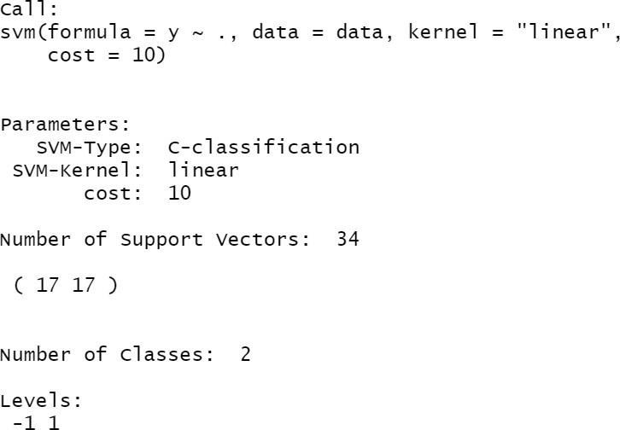

Inference: From the above output there were 34 support vectors, 17 in one class and 17 in another class.
plot(svm,data)
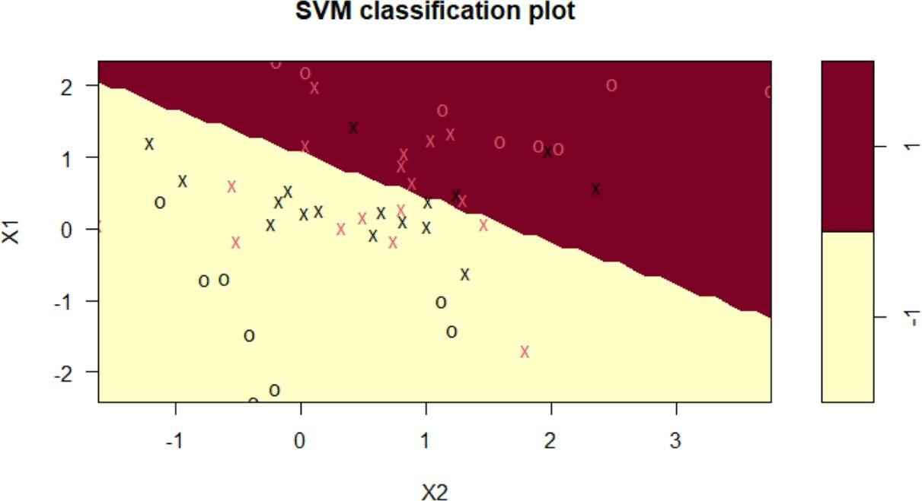

Inference: The support vectors as crosses and the remaining observations are plotted as circles.

Viva Questions:
1 Define SVM?
Support Vector Machine or SVM is one of the most popular Supervised Learning algorithms, which is used for Classification as well as Regression problems.
- Define Hyperplane?
There can be multiple lines/decision boundaries to segregate the classes in n-dimensional space, but we need to find out the best decision boundary that helps to classify the data points. This best boundary is known as the hyperplane of SVM.
- Define support vectors?
The data points or vectors that are the closest to the hyperplane and which affect the position of the hyperplane are termed as Support Vector. Since these vectors support the hyperplane, hence called a Support vector.

- Dimensionality reduction with PCA in R and K-means Clustering in R
  - Principal Component Analysis (PCA) in R R Code:
Store the Data in Excel and Export the Data
PCA=prcomp(Data, scale=T) summary(PCA)
- Example: Obtain the percentage of principal components to the following data and interpret the results
A | 38 | 35 | 36 | 38 | 35 | 30 | 38 | 30 | 26 | 32 | 35 | 36 | 31 | 38 | 35 | 30 | 29
B | 61 | 61 | 62 | 65 | 60 | 61 | 61 | 62 | 60 | 58 | 56 | 57 | 58 | 65 | 60 | 62 | 52
C | 33 | 33 | 65 | 67 | 59 | 33 | 33 | 56 | 60 | 62 | 61 | 60 | 52 | 67 | 59 | 56 | 59
D | 32 | 32 | 27 | 34 | 43 | 32 | 32 | 44 | 48 | 52 | 33 | 39 | 42 | 34 | 43 | 44 | 56
E | 50 | 50 | 31 | 33 | 36 | 50 | 50 | 35 | 31 | 30 | 32 | 29 | 30 | 33 | 36 | 35 | 31
F | 38 | 35 | 54 | 57 | 70 | 30 | 38 | 72 | 77 | 49 | 50 | 51 | 56 | 57 | 70 | 72 | 52
G | 65 | 60 | 65 | 74 | 60 | 62 | 65 | 62 | 61 | 68 | 58 | 62 | 61 | 74 | 60 | 62 | 63

R Code with Output:
Store the Data in Excel and Export the Data PCA=prcomp(PCA_DATA,scale=T) summary(PCA)
summary(PCA)
Importance of components:
PC1 PC2 PC3 PC4 PC5 PC6 PC7 Standard deviation 1.7831 1.4249 0.9095 0.79309 0.52442 0.18045 0.16253
Proportion of Variance0.4542 0.2901 0.1182 0.08986 0.03929 0.00465 0.00377
Cumulative Proportion 0.4542 0.7443 0.8624 0.95229 0.99157 0.99623 1.00000

Inference: PC1 explains 45% ,PC2 explains 29% ,PC3 explains 11% of the variation ,implies maximum information in the dataset out of seven variables can be encapsulated by these three principal components PC1,PC2,PC3.

- Example: Obtain the percentage of principal components to the following data and interpret the results

X1 | 44 | 33 | 33 | 32 | 34 | 31 | 33 | 30 | 34 | 34 | 33 | 36 | 33 | 34 | 37
X2 | 1.3 | 2.2 | 2.2 | 2.6 | 2 | 1.8 | 2.2 | 3.6 | 1.6 | 1.5 | 2.2 | 1.7 | 2.2 | 1.3 | 2.6
X3 | 250 | 115 | 75 | 85 | 100 | 75 | 85 | 75 | 225 | 250 | 255 | 175 | 75 | 85 | 90
X4 | 0.63 | 0.59 | 0.56 | 0.55 | 0.54 | 0.59 | 0.56 | 0.46 | 0.63 | 0.6 | 0.63 | 0.58 | 0.55 | 0.57 | 0.62

R Code with Output:
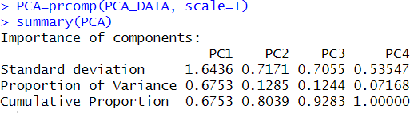
PCA=prcomp(PCA_DATA, scale=T) summary(PCA)
Inference: PC1 explains 67% of the total variance implies two-third of information in the dataset out of four variables can be encapsulated by one PC1. PC2 and PC3 explains 12 % each. From the above components, one can observe that first variable corresponding to the X1 factor
can be included in the model.
  - K-means Clustering in R Algorithm:
- Install appropriate package
- Store the Data in Excel and Export the Data
- Choose k value by any one of the three methods
- Apply kmeans clustering to the given data.
R Code:
install.packages("factoextra") # To visualize the clusters
library(factoextra)

# To choose k value: 3 methods are (Elbow, Silhouette, Gap)
fviz_nbclust(Data, kmeans, method = "wss", k.max = 8) #k.max argument is optional
or
fviz_nbclust(Data, kmeans, method = "silhouette", k.max = 8) or
fviz_nbclust(Data, kmeans, method = "gap", k.max = 8)
#From the above 3 methods k value will be taken clust=kmeans(Data, k value)

clust
fviz_cluster(clust, Data) #Displays cluster plot
- Example: The following is the set of 10 data points. Cluster these points using R code in k means algorithm.
S.No. | 1 | 2 | 3 | 4 | 5 | 6 | 7 | 8 | 9 | 10
X1 | 18 | 22 | 25 | 32 | 38 | 42 | 44 | 46 | 52 | 60
X2 | 12 | 18 | 25 | 28 | 32 | 38 | 40 | 43 | 45 | 50
X3 | 18 | 22 | 35 | 38 | 39 | 43 | 50 | 55 | 60 | 65
R Code with Output: install.packages("factoextra") library(factoextra)
fviz_nbclust(PCA_Data, kmeans, method = "wss", k.max = 8)
Optimal number of clusters

5000

4000
Total Within Sum of Square

3000

2000

1000

0
1 2 3 4 5 6 7 8
Number of clusters k

Choose K=2 clust=kmeans(PCA_Data,2) clust

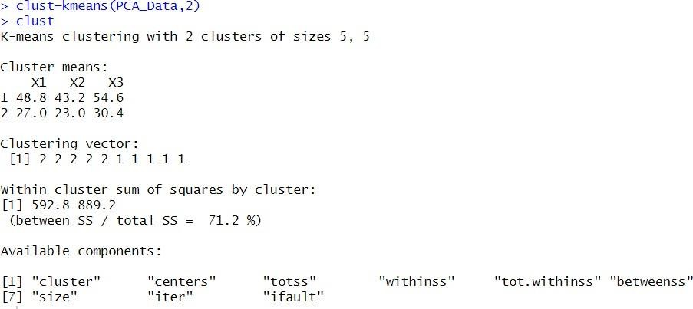
fviz_cluster(clust,PCA_Data)
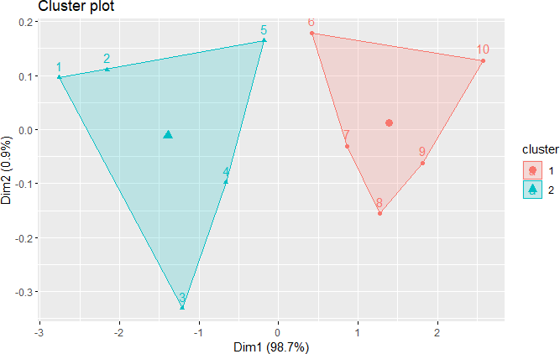

- Example: Cluster these data points using R code in k means algorithm.
X1 | 73 | 63 | 65 | 60 | 62 | 61 | 71 | 72 | 73 | 63 | 59 | 60 | 71 | 72 | 65
X2 | 60 | 62 | 61 | 63 | 60 | 56 | 65 | 64 | 60 | 62 | 62 | 62 | 65 | 64 | 55
X3 | 48 | 45 | 45 | 45 | 47 | 41 | 41 | 42 | 48 | 45 | 41 | 43 | 41 | 42 | 42
X4 | 38 | 44 | 74 | 70 | 68 | 42 | 32 | 35 | 38 | 44 | 35 | 30 | 32 | 35 | 56
X5 | 70 | 77 | 52 | 67 | 65 | 66 | 65 | 60 | 70 | 77 | 62 | 61 | 65 | 60 | 52
X6 | 65 | 63 | 62 | 67 | 65 | 64 | 58 | 62 | 65 | 63 | 60 | 56 | 58 | 62 | 62

R Code with Output: install.packages("factoextra") library(factoextra)
fviz_nbclust(PCA_Data, kmeans, method = "wss", k.max = 11)

fviz_nbclust(DATA, kmeans, method = "wss", k.max = 11)

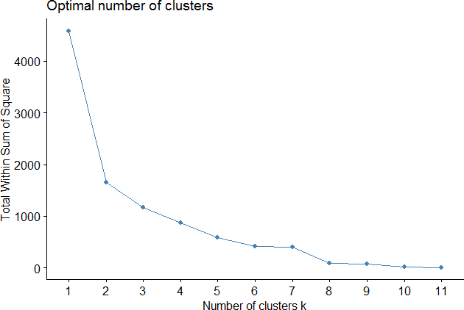

Choose K=2 clust=kmeans(PCA_Data,2) clust
K-means clustering with 2 clusters of sizes 4, 11

Cluster means:  Y1 Y2 | Y3 | Y4 | Y5 | Y6
1 63.00000 59.75 44.75000 |  | 67.00000 | 59.00000 | 64.00000
2 67.09091 62.00 43.36364 |  | 36.81818 | 66.63636 | 61.45455

Clustering vector:
[1] 2 2 1 1 1 2 2 2 2 2 2 2 2 2 1
Within cluster sum of squares by cluster:
[1] 461.500 1192.364
(between_SS / total_SS = 63.9 %) Available components:
[1] "cluster" " | "centers" | "totss" | "withinss" | "tot.withinss
[6] "betweenss" | "size" | "iter" | "ifault"

fviz_cluster(clust,DATA)

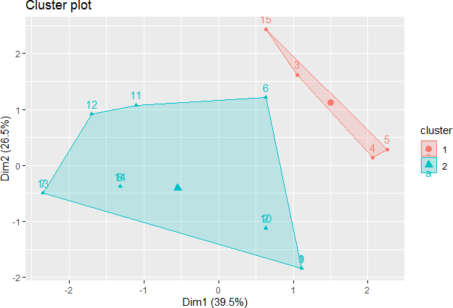

Viva Questions:

  - Define Cluster.
Cluster is defined as collections or groups of items with similar or different characteristics.

  - Define Principal Components.
Principal component analysis (PCA) is a statistical procedure that uses an orthogonal transformation to convert a set of observations of possibly correlated variables (entities each of which takes on various numerical values) into a set of values of linearly uncorrelated variables called principal components.
  - What kind of Machine learning did PCA and Clustering techniques?
PCA and Clustering techniques belongs to Un supervised Machine Learning .

- Kernel SVM in R Kernel SVM:
R Code:
install.packages("e1071") library(e1071)
x = matrix(rnorm(32), 16, 2) #Generating the data
y = rep(c(-1, 1), c(8, 8)) #Assigning +1 and -1 to the above data
x[y == 1,] = x[y == 1,] + 1 #bias the x variable when y =1
dat = data.frame(x, y = as.factor(y)) #representing the above data in table form using dataframe
svm = svm(y ~ ., data = dat, kernel = "radial",gamma=1,cost=1) summary(svm)
plot(svm,dat)

- Example: Write R code to find the number of support vectors for classifying the data in radial basis kernel. Data as follows: 400 observations, in two columns and also get the SVM classification plot.
R Code with Output:
R Code with Output:
x = matrix(rnorm(400), 200, 2)
y = rep(c(-1, 1), c(100, 100))
x[y == 1,] = x[y == 1,] + 1
data = data.frame(x, y = as.factor(y))
svm = svm(y ~ ., data = data, kernel = "radial",gamma=1, cost=1) summary(svm)
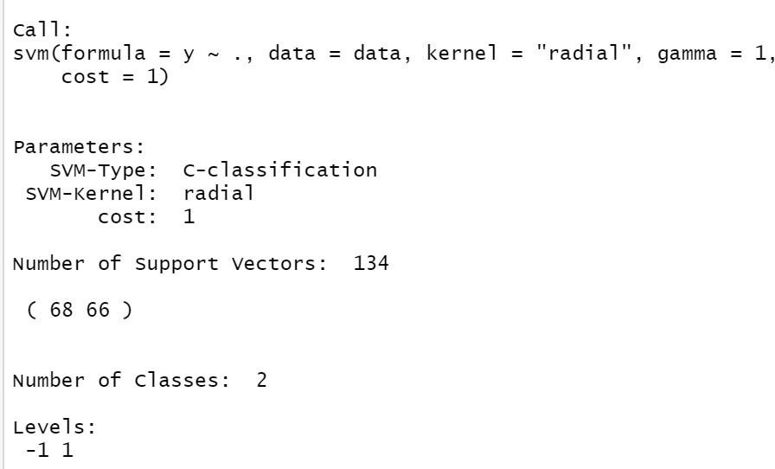

Inference: From the above output there were 134 support vectors, 68 in one class and 66 in another class.
plot(svm,data)
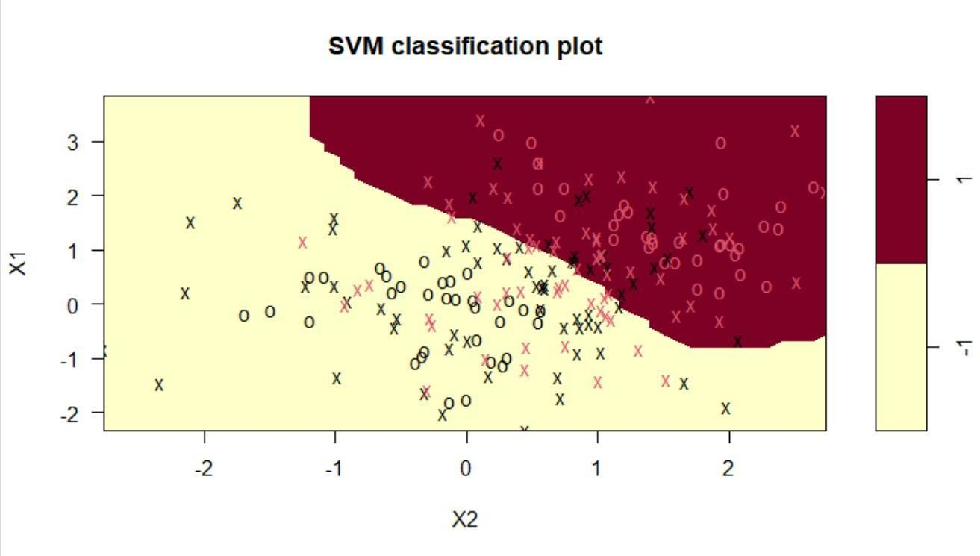

- Example: Write R code to find the number of support vectors for classifying the data in radial basis kernel. Data as follows: 300 observations, in two columns and also get the SVM classification plot.
R Code with Output:
R Code with Output:
x = matrix(rnorm(300), 150, 2)
y = rep(c(-1, 1), c(75, 75))
x[y == 1,] = x[y == 1,] + 1
data = data.frame(x, y = as.factor(y))
svm = svm(y ~ ., data = data, kernel = "radial",gamma=1, cost=10) summary(svm)
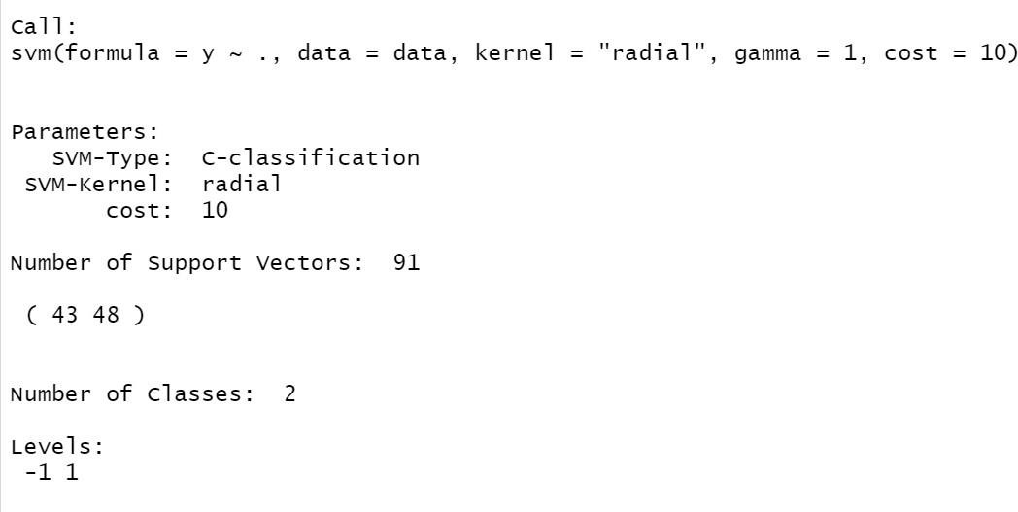
Inference: From the above output there were 91 support vectors, 43 in one class and 48 in another class.
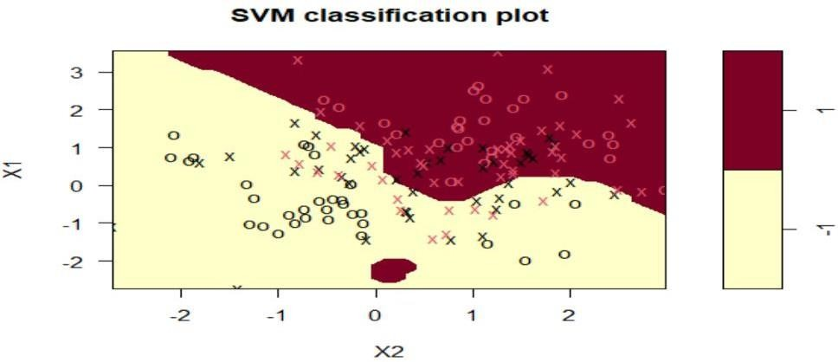

Viva Questions:
- Define Kernel.
Kernel Function is a method used to take data as input and transform it into the required form of processing data. “Kernel” is used due to a set of mathematical functions used in
Support Vector Machine providing the window to manipulate the data.

- What is the use of Kernel

In machine learning, a “kernel” is usually used to refer to the kernel trick, a method of using a linear classifier to solve a non-linear problem.

List of Additional programs
- Generating Functions (Binomial, Poisson, Uniform, Normal and Exponential) using R programming
  - Uniform Distribution R Code:
runif(n, min, max)
    - Example: Generate 5 Uniform random numbers from 10 to 100.

R Code with Output:
runif(5,10,100)
[1] 42.61054 57.56261 23.57929 76.08863 25.25279

    - Example: Generate 10 random samples from the Uniform Distribution U(0,1)
R Code with Output:
runif(10,0,1)
[1] 0.67139102 0.34191665 0.50767938 0.89660762 0.05948337 0.65363865
[7] 0.83952941 0.12345681 0.97254724 0.75465741
  - Normal Distribution R Code:
rnorm(n, mean, sd)

    - Example: Generate four random numbers from N (70, 10)
R Code with Output:
rnorm(4,70,sqrt(10))
[1] 74.84571 70.68275 67.49411 67.07436

    - Example: Generate 5 Random samples from the Normal distribution N (25,4)
R Code with Output: rnorm(5,25,sqrt(4))

[1] 24.53206 24.90118 29.06580 23.51796 23.38991

  - Binomial Distribution

R Code:
rbinom(no of random numbers to be generate, n, p)
    - Example: Generate 6 Random samples from the Binomial distribution B (10, 0.5)

R Code with Output:
rbinom(6,10,0.5)
[1] 4 5 6 6 5 5

  - Exponential Distribution R Code:
rexp(n, theta )

    - Example: Generate 5 Random samples from the Exponential distribution with parameter 10
R Code with Output:
rexp(5,10)
[1] 0.007909765 0.021077747 0.182569774 0.156448570 0.125258499

    - Fit linear regression to the given data

Hours: 1, 2, 4, 5, 5, 6, 6, 7, 8, 10, 11, 11, 12, 12, 14

Score: 64, 66, 76, 73, 74, 81, 83, 82, 80, 88, 84, 82, 91, 93, 89

R Code with output:

df<-data.frame(hours=c(1, 2, 4, 5, 5, 6, 6, 7, 8, 10, 11, 11, 12, 12, 14),
score=c(64, 66, 76, 73, 74, 81, 83, 82, 80, 88, 84, 82, 91, 93, 89))
head(df) # Displays the first 6 values in the data hours score
1 1 64
2 2 66
3 4 76
4 5 73
5 5 74
6 6 81

attach(df)
model <- lm(score~hours) summary(model)

Call:

lm(formula = score ~ hours)

Residuals:
Min 1Q Median 3Q Max
-5.140 -3.219 -1.193 2.816 5.772

Coefficients:
Estimate Std. Error t value Pr(>|t|) (Intercept) 65.334 2.106 31.023 1.41e-13 ***
hours 1.982 0.248 7.995 2.25e-06 ***
---
Signif. codes: 0 ‘***’ 0.001 ‘**’ 0.01 ‘*’ 0.05 ‘.’ 0.1 ‘ ’ 1

Residual standard error: 3.641 on 13 degrees of freedom Multiple R-squared: 0.831, Adjusted R-squared: 0.818
F-statistic: 63.91 on 1 and 13 DF, p-value: 2.253e-06

INFERENCE:

In this model output intercept and hours variable are significant because its p-values are less than 0.05 so these are included in th modl equation.
The model equation is
Score =65.334+1.982*hours
The Multiple R-square value is 0.831 ,so the variable hours explains 83% variation in the dependent variable ‘score’.
F –test is used to test the overall significant of the model H0: The model is not significant to the data
H1:the model is significant to the data
The p-value for this f statistic is less than 0.05 so we reject H0.Therefore the model is significant to the data.

    - Multiple linear regression
Testing overall hypothesis and testing significance of individual variables, model selections and prediction in R programming is called Multiple linear regression.
R Code:
lm(y ~ x1+x2+x3...,data)

Example 1: Fit a multiple linear regression to the following data set.

S.No. | 1 | 2 | 3 | 4 | 5 | 6 | 7 | 8 | 9 | 10 | 11 | 12
X1 | 70 | 77 | 72 | 77 | 74 | 80 | 82 | 74 | 72 | 77 | 90 | 82
X2 | 100 | 105 | 112 | 105 | 125 | 112 | 129 | 125 | 112 | 105 | 140 | 129
X3 | 125 | 110 | 118 | 110 | 122 | 123 | 121 | 122 | 118 | 110 | 128 | 121
X4 | 65 | 70 | 66 | 70 | 58 | 68 | 61 | 58 | 66 | 70 | 82 | 61
Y | 77 | 73 | 68 | 76 | 73 | 77 | 80 | 73 | 72 | 74 | 66 | 78

R Code with Output:
Left for student exercise.

Programme Outcomes

S N  o. | CO | Name of the Programme | Outcome of the Programme | Mention any Real-time application where we can apply this  method | Which one is more efficient
1 | CO1 | Introduction to R Programming | Perform built-in commands and operations with matrices in R- programming.  Analyze the appropriate data type of  variables and evaluate various Frequency Distributions in R -  programming. Determine the mean and standard deviation of a sampling distribution using R. | R is a open source Software and it can be easily accessed. It represents the whole set of data by a single value. and gives us the location of central points.
1 | CO1 | Introduction to descriptive statistics using R (Frequency Distribution and Cumulative  Distribution Function)
1 | CO1 | Acceptance/Rejection  Sampling in R
1 | CO1 | Maximum likelihood and method of moments estimation.
2 | CO2 | Testing of Hypothesis based on Z-test. Concept of p-value in R. Testing of hypothesis based on t-test, chi-square test and F-test.  Confidence interval estimation in R | Develop a code for testing of hypothesis using Z-test, t- test, chi-square- test, F-test.  Classify Linear and Logistic regression. | To test the significance of hypothesis based on the p-value
3 | CO3 | Multiple linear regression: Outlier analysis, residual analysis, test for normality, multi-  collinearity in R |  | To classify the objects into groups
3 | CO3 | Logistic Regression in R |  | To classify the objects into groups
4 | CO4 | Classification with SVM in R | Write Code for SVM and  Kernel SVM methods. | To classify the objects into groups when the data is large.
4 | CO4 | Dimensionality reduction with PCA in R and K-  means Clustering in R | Write Code for SVM and  Kernel SVM methods. | To classify the objects into groups when the data is large.
4 | CO4 | Kernel SVM in R | Write Code for SVM and  Kernel SVM methods. | To classify the objects into groups when the data is large.









